CHAPTER 1

INTRODUCTION

Context:
In today’s fast-paced digital world, online recruitment platforms have become a primary source for students and job seekers to find internships and employment opportunities. From job portals and social media to messaging applications, access to opportunities has become faster and more convenient. However, this convenience has also led to a significant rise in fraudulent job and internship postings that deceive users through fake offers, unrealistic stipends, and misleading information. Traditional methods of verifying job authenticity—such as asking peers or manually checking company details—are often time-consuming, unreliable, and lack transparency.
The rapid growth of digital platforms has created a need for intelligent and automated solutions that can detect recruitment fraud efficiently. In this context, an AI and graph-based detection system is developed to identify fake internship and job postings. The system uses Natural Language Processing (NLP) techniques with Logistic Regression and TF-IDF to analyze textual data and detect suspicious patterns in job descriptions, emails, and messages.
In addition to text analysis, graph-based techniques are used to uncover hidden relationships between entities such as phone numbers, email addresses, and domains. This helps in identifying repeated patterns and coordinated fraudulent activities that may not be visible from individual posts. The system provides a user-friendly dashboard developed using Streamlit, offering real-time alerts, risk scores, and visual insights for better decision-making.
Furthermore, the platform supports monitoring and management of suspicious job postings, improving detection accuracy and efficiency. It is also designed to be scalable, allowing integration with multiple job platforms and expansion for future enhancements. By bridging the gap between job seekers and safe opportunities using advanced technology, the system promotes a more secure, transparent, and trustworthy online recruitment ecosystem.

1.2 Problem Statement
Despite the rapid growth of online recruitment platforms, students and job seekers face many challenges due to the increasing number of fake job and internship postings. These fraudulent postings often use attractive offers, fake company names, and misleading information to deceive users. Below are the key problems addressed by this project.

1.2.1) Lack of a Centralized Verification System
There is no single platform where users can easily verify whether a job or internship is genuine or fake. People often depend on different sources, which is confusing and time-consuming.

1.2.2) Difficulty in Identifying Fake Job Posts
Many fake job postings look real and professional, making it hard for students to identify scams. Without proper tools, users may trust and apply to fraudulent opportunities.

1.2.3) Reuse of Fraudulent Contact Details
Scammers often reuse the same phone numbers, email addresses, and website links across multiple job postings. These hidden connections are difficult to detect manually.

1.2.4) Lack of Awareness and Transparency
Job seekers may not be aware of common fraud patterns like advance payment requests, fake interviews, or unrealistic salary offers. This lack of awareness increases the risk of being scammed.

1.2.5) Time-Consuming Manual Verification
Checking company details, websites, and contacts manually takes a lot of time and effort, and still may not guarantee accuracy.

1.2.6) No Real-Time Alerts or Detection System
Most platforms do not provide real-time warnings about suspicious job postings, leaving users vulnerable to fraud.

1.2.7) Absence of Relationship Analysis
Traditional systems only analyze individual job posts and do not identify relationships between multiple posts. This makes it difficult to detect organized fraud networks.

1.2.8) Lack of Reliable Monitoring Tools
There are limited tools available for administrators or institutions to monitor and manage suspicious job postings effectively.

1.2.9) Risk to Students and Job Seekers
Students and freshers are more vulnerable as they are actively searching for opportunities and may trust fake offers easily, leading to financial loss or data theft.

1.2.10) Scalability Issues in Manual Systems
Manual methods cannot handle the large volume of job postings generated daily across different platforms.
1.3 Proposed Solution
To address the challenges of increasing fraudulent job and internship postings, an AI & Graph-Based Detection System is proposed. This system is designed to automatically identify suspicious recruitment activities and provide a safe environment for students and job seekers. Below are the key components of the solution:

1.3.1) User-Friendly Dashboard
The system provides a simple and interactive dashboard developed using Streamlit. Users can easily upload or view job postings, check risk levels, and monitor alerts. The interface is designed to be easy to use for both technical and non-technical users.

1.3.2) Text Analysis using AI & NLP
The system uses Natural Language Processing (NLP) with Logistic Regression and TF-IDF to analyze job descriptions, emails, and messages. It detects suspicious patterns such as unrealistic salaries, urgent hiring, or payment requests.

1.3.3) Graph-Based Relationship Analysis
The system builds a graph of entities like phone numbers, email addresses, and domains. It identifies hidden connections and detects repeated use of the same contact details across multiple postings, helping to uncover fraud networks.

1.3.4) Automated Fraud Detection & Risk Scoring
Each job post is assigned a risk score based on text analysis and graph connections. High-risk posts are automatically flagged as suspicious, allowing users to avoid potential scams.

1.3.5) Real-Time Alerts and Notifications
The system generates real-time alerts for suspicious job postings. Users and administrators are notified immediately when high-risk activity is detected.

1.3.6) Admin Panel for Monitoring
An admin dashboard allows monitoring of all job postings, flagged cases, and detected fraud patterns. Admins can verify, manage, and take action on suspicious data.

1.3.7) Data Management and Tracking
The system maintains records of job postings, detected fraud cases, and entity relationships. This helps in tracking repeated scams and improving detection accuracy over time.

1.3.8) Scalable and Efficient System
The system is designed to handle large volumes of data from multiple platforms. It can be expanded in the future to include more data sources and advanced detection techniques.

CHAPTER 2

METHODOLOGY

2.1 Python
Python is the primary programming language used for implementing the system. It is widely used in data science and machine learning due to its simplicity and extensive library support. Python enables efficient handling of large datasets, text processing, and model building. Libraries such as pandas and NumPy are used for data manipulation, while other libraries support machine learning and graph operations.

2.2 Natural Language Processing (NLP)
Natural Language Processing (NLP) is used to analyse and understand the textual content of job postings. Since most recruitment data is unstructured (job descriptions, emails, messages), NLP techniques help convert this text into meaningful information. The system identifies suspicious patterns such as:
- Unrealistic salary offers
- Urgent hiring language (e.g., “apply immediately”)
- Requests for payment or personal information
NLP enables the system to detect fraud indicators that are not obvious through manual inspection.

2.3 TF-IDF (Term Frequency–Inverse Document Frequency)
TF-IDF is used for feature extraction from text data. It converts textual information into numerical vectors that can be processed by machine learning models.
- Term Frequency (TF): Measures how frequently a word appears in a document
- Inverse Document Frequency (IDF): Reduces the importance of common words
By combining TF and IDF, the system highlights important keywords that may indicate fraudulent behavior. This improves the accuracy of classification.

2.4 Logistic Regression
Logistic Regression is used as the classification algorithm to predict whether a job posting is genuine or fake. It is a supervised machine learning model suitable for binary classification problems.
- Input: TF-IDF feature vectors
- Output: Probability score (fake or genuine)
The model is trained on labeled data and learns patterns associated with fraudulent postings. It is efficient, easy to interpret, and performs well for this type of problem.

2.5 Graph-Based Analysis
Graph-based analysis is a key component of the system. It helps in detecting relationships between different entities involved in job postings.
- Nodes: Job posts, phone numbers, email addresses, domains
- Edges: Connections between entities (e.g., same phone number used in multiple posts)
By constructing a graph, the system can:
- Identify repeated use of contact details
- Detect clusters of suspicious posts
- Uncover hidden fraud networks
This approach goes beyond text analysis and provides deeper insights into coordinated scam activities.

2.6 Data Pre-processing Techniques
Data pre-processing is performed to clean and prepare the data before analysis. This includes:
- Removing special characters and unnecessary symbols
- Converting text to lowercase
- Tokenization (splitting text into words)
- Extracting entities like phone numbers, emails, and URLs
Proper pre-processing improves data quality and enhances model performance.

2.7 Dashboard and Visualization
A user-friendly dashboard is developed using Streamlit to display the results of the system. The dashboard provides:
- Risk scores for each job posting
- Alerts for suspicious activities
- Graph visualizations showing connections between entities
This helps users and administrators easily understand and interpret the results.

2.8 Alert and Monitoring System
The system includes an automated alert mechanism that generates notifications when suspicious job postings are detected.
- High-risk posts are flagged
- Alerts are displayed on the dashboard
- Administrators can take necessary action
This ensures real-time monitoring and quick response to potential fraud.

2.9 Scalability and Performance
The system is designed to handle large volumes of job data from multiple sources. It can be extended in the future by:
- Adding more data sources (job portals, APIs)
- Improving models with advanced techniques
- Integrating real-time data processing

CHAPTER 3
DIAGRAM

Use Case Diagram
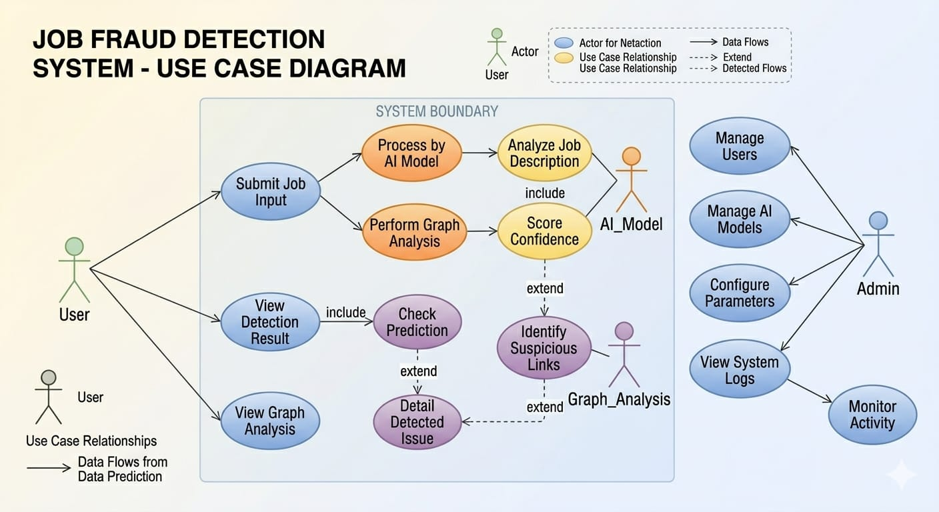
Figure 1

Entity Relationship Diagram
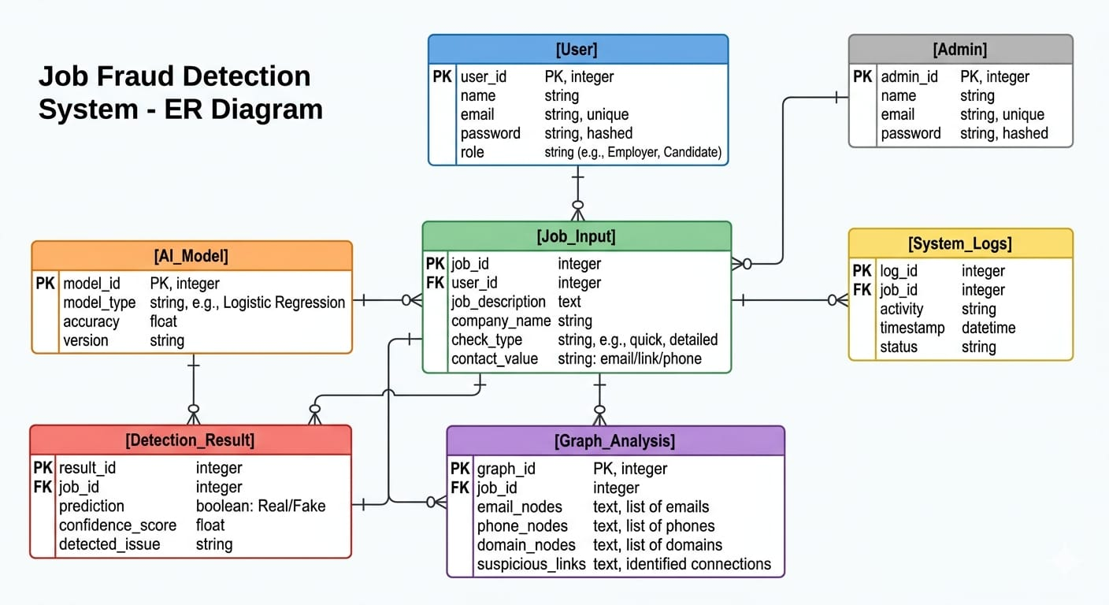

Figure 2

Activity Diagram
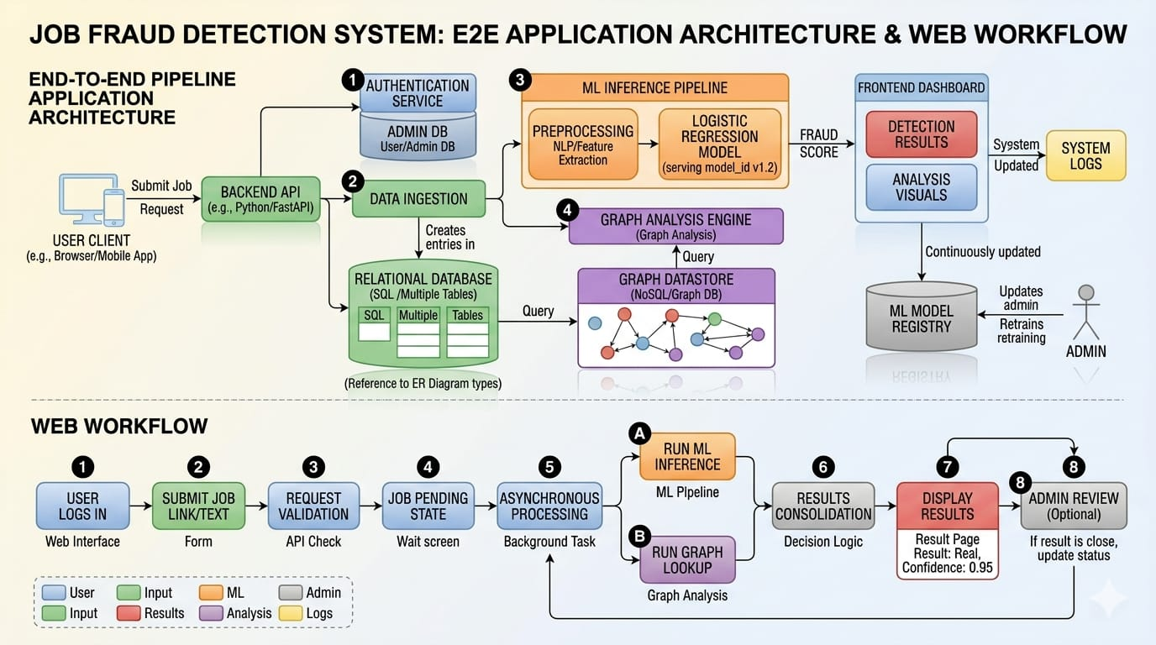
Figure 3

CHAPTER 4
TOOLS AND REQUIRNMENTS

4.1) Visual Studio Code
Visual Studio Code (VS Code) is a lightweight, open-source, and highly efficient code editor developed by Microsoft. It is designed to provide a powerful yet simple development environment for writing, editing, debugging, and managing code. VS Code supports a wide range of programming languages and frameworks, making it suitable for various domains such as web development, data science, machine learning, and software engineering.
Due to its high performance, flexibility, and extensibility, VS Code has become one of the most popular development tools among students, researchers, and professional developers. Its user-friendly interface and customizable features allow developers to efficiently manage both small scripts and large-scale applications.

Key Features of Visual Studio Code

1. Multi-language Support
VS Code provides built-in support for many programming languages such as Python, JavaScript, Java, C++, HTML, and TypeScript. It includes features like syntax highlighting, code formatting, and bracket matching.
Additionally, developers can install extensions to support other languages such as Go, Rust, and Dart. This flexibility makes VS Code a universal editor capable of handling multiple programming environments within a single platform.

2. Extensions Marketplace
The Extensions Marketplace is one of the most powerful features of VS Code. It provides thousands of extensions that enhance the functionality of the editor.
Some commonly used extensions include:
- Python Extension (for machine learning and data science)
- ESLint (for code quality checking)
- Prettier (for automatic code formatting)
- Jupyter (for running notebooks inside VS Code)
These extensions allow developers to customize the editor according to project requirements.

3. Integrated Terminal
VS Code includes a built-in terminal that allows developers to execute commands directly within the editor.
Key benefits:
- Run Python scripts and programs
- Install libraries using pip
- Execute Git commands
- Manage project files
The integrated terminal supports multiple sessions, enabling developers to perform several tasks simultaneously without switching applications.

4. Version Control Integration
VS Code has built-in support for Git, which is essential for managing code versions.
Features include:
- Tracking changes in files
- Committing updates
- Branch creation and merging
- Conflict resolution
It also integrates with platforms like GitHub and GitLab, making collaboration easier in team projects.

5. IntelliSense (Smart Code Completion)
IntelliSense is an advanced feature that provides intelligent code suggestions. It includes:
- Auto-completion of code
- Parameter hints
- Function definitions
- Error detection
This feature improves coding speed, reduces errors, and helps beginners learn syntax more effectively.

6. Debugging Support
VS Code provides a powerful debugging system that helps identify and fix errors in the code.
Developers can:
- Set breakpoints
- Step through code execution
- Monitor variables
- Analyze call stacks
It supports debugging for multiple programming languages, either natively or through extensions.

7. Customization and Personalization
VS Code allows developers to customize the editor according to their preferences.
Customization options include:
- Themes (dark/light mode)
- Fonts and layout
- Keyboard shortcuts
- Workspace settings
Configuration files (JSON) can be used to save and share settings across different systems.

8. Live Share (Real-time Collaboration)
Live Share enables real-time collaboration among developers.
Features include:
- Sharing code with team members
- Collaborative editing
- Shared debugging sessions
- Terminal sharing
This feature is highly useful for remote teamwork and group projects.

9. Cross-platform Compatibility
VS Code works seamlessly across different operating systems, including:
- Windows
- macOS
- Linux
This ensures that developers can work in any environment without compatibility issues.

10. Performance and Lightweight Design
VS Code is designed to be fast and lightweight. It uses minimal system resources compared to traditional IDEs, making it suitable even for low-end systems.
Despite being lightweight, it provides powerful features similar to full-scale IDEs.

11. Use Case Versatility
VS Code is suitable for a wide range of development tasks, such as:
- Web development (HTML, CSS, JavaScript)
- Backend development
- Data analysis and visualization
- Machine learning and AI projects
- Graph-based system development
Its flexibility makes it ideal for projects like AI & Graph-Based Fake Job Detection.

12. Community Support and Updates
VS Code has a large and active developer community.
Advantages:
- Regular updates from Microsoft
- Availability of tutorials and documentation
- Community-driven extensions
- Quick bug fixes and feature improvements

4.2) Jupyter Notebook

1. Jupyter Notebook
Jupyter Notebook is used as the primary development environment for building and testing the system. It allows step-by-step execution of code, which is very useful for data analysis, model training, and debugging. Each step—data loading, pre-processing, feature extraction, model training, and evaluation—can be executed in separate cells, making the workflow clear and easy to understand. It also supports inline visualization, allowing graphs and results to be displayed directly within the notebook.

2. Python (Programming Language)
Python is the core programming language used in the project. It is widely used in data science and machine learning because of its simplicity and powerful libraries. Python is used for:
- Data preprocessing
- Feature extraction
- Machine learning model implementation
- Graph construction and analysis
Its flexibility allows integration of all components of the system in a single environment.

3. Pandas (Data Handling Library)
Pandas is used for data manipulation and preprocessing. It helps in:
- Loading datasets from CSV/Excel files
- Cleaning and filtering data
- Handling missing or inconsistent values
- Structuring data into DataFrames for easy processing
Pandas plays a key role in preparing the dataset before applying machine learning algorithms.

4. NumPy (Numerical Computation Library)
NumPy is used for efficient numerical operations. It supports array-based computations and mathematical functions required for machine learning. It improves performance when working with large datasets.

5. Natural Language Processing (NLP)
NLP techniques are used to process textual job data such as job descriptions, emails, and messages. Since recruitment data is unstructured, NLP helps in converting text into meaningful patterns. The system identifies suspicious keywords and phrases such as:
- “Earn high salary instantly”
- “Pay registration fee”
- “Urgent hiring”
This improves the system’s ability to detect fraudulent job postings.

6. TF-IDF (Feature Extraction Technique)
TF-IDF (Term Frequency–Inverse Document Frequency) is used to convert text into numerical vectors.
- It assigns higher importance to unique and relevant words
- Reduces the weight of commonly used words
This helps the model focus on important terms that indicate fraud, improving classification accuracy.

7. Scikit-learn (Machine Learning Library)
Scikit-learn is used to implement machine learning algorithms and evaluation techniques. It provides:
- TF-IDF Vectorizer for feature extraction
- Logistic Regression for classification
- Train-test split for model validation
- Accuracy, precision, recall metrics for evaluation
It is efficient, easy to use, and well-suited for classification tasks.

8. Logistic Regression (Classification Model)
Logistic Regression is used as the main classification algorithm. It predicts whether a job posting is fake or genuine.
- Input: TF-IDF feature vectors
- Output: Probability score (0 = genuine, 1 = fake)
It is simple, fast, and performs well for binary classification problems.

9. NetworkX (Graph Analysis Library)
NetworkX is used to create and analyze graphs. In this project:
- Nodes represent job posts, phone numbers, emails, and domains
- Edges represent relationships between these entities
It helps in:
- Detecting repeated use of contact details
- Identifying clusters of suspicious postings
- Uncovering hidden fraud networks
Graph analysis adds an extra layer of detection beyond text analysis.

10. Matplotlib / Seaborn (Visualization Tools)
These libraries are used for data visualization. They help in:
- Plotting data distributions
- Visualizing model performance
- Displaying graph structures
Visual representation makes it easier to interpret results and patterns.

11. Dataset (Training and Testing Data)
The system uses a dataset containing both genuine and fake job postings. This dataset is used to:
- Train the machine learning model
- Test its performance
- Evaluate accuracy and reliability
Proper dataset selection is important for achieving good results.

12. Integration with Dashboard
The processed results from Jupyter Notebook can be integrated into a dashboard developed using Streamlit. This allows real-time visualization of:
- Risk scores
- Alerts
- Graph connections

CHAPTER 5
CODE SNAPSHOTS AND OUTPUT

5.1 AI & GRAPH BASED DETECTION OF FAKE INTERNSHIP/JOB (Code)

5.1.1) app.py
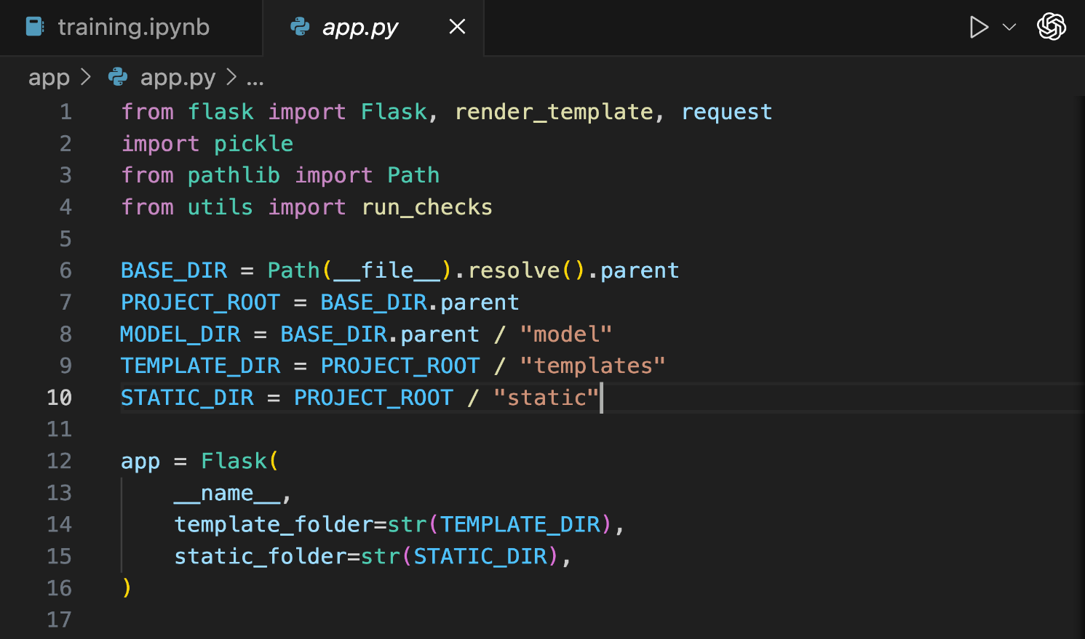
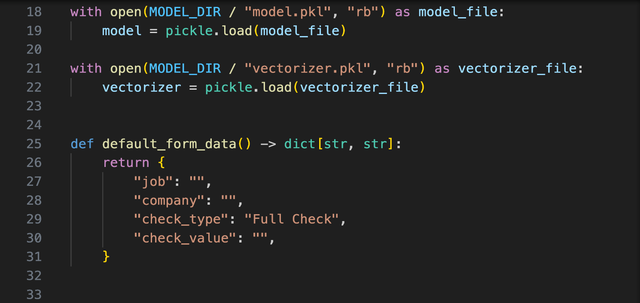
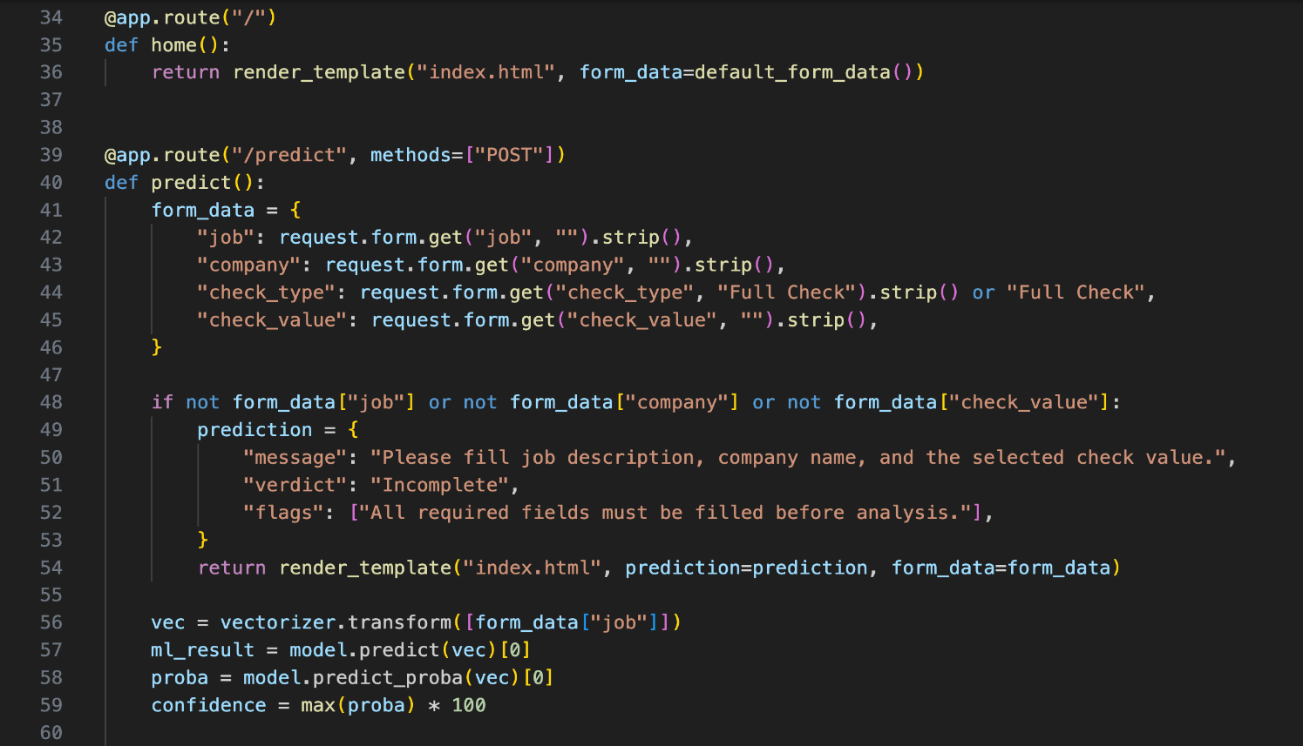
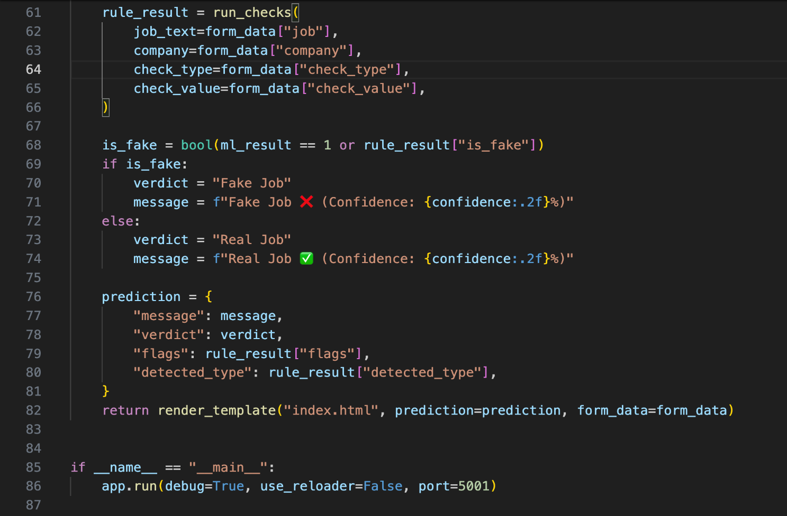

5.1.2) utils.py
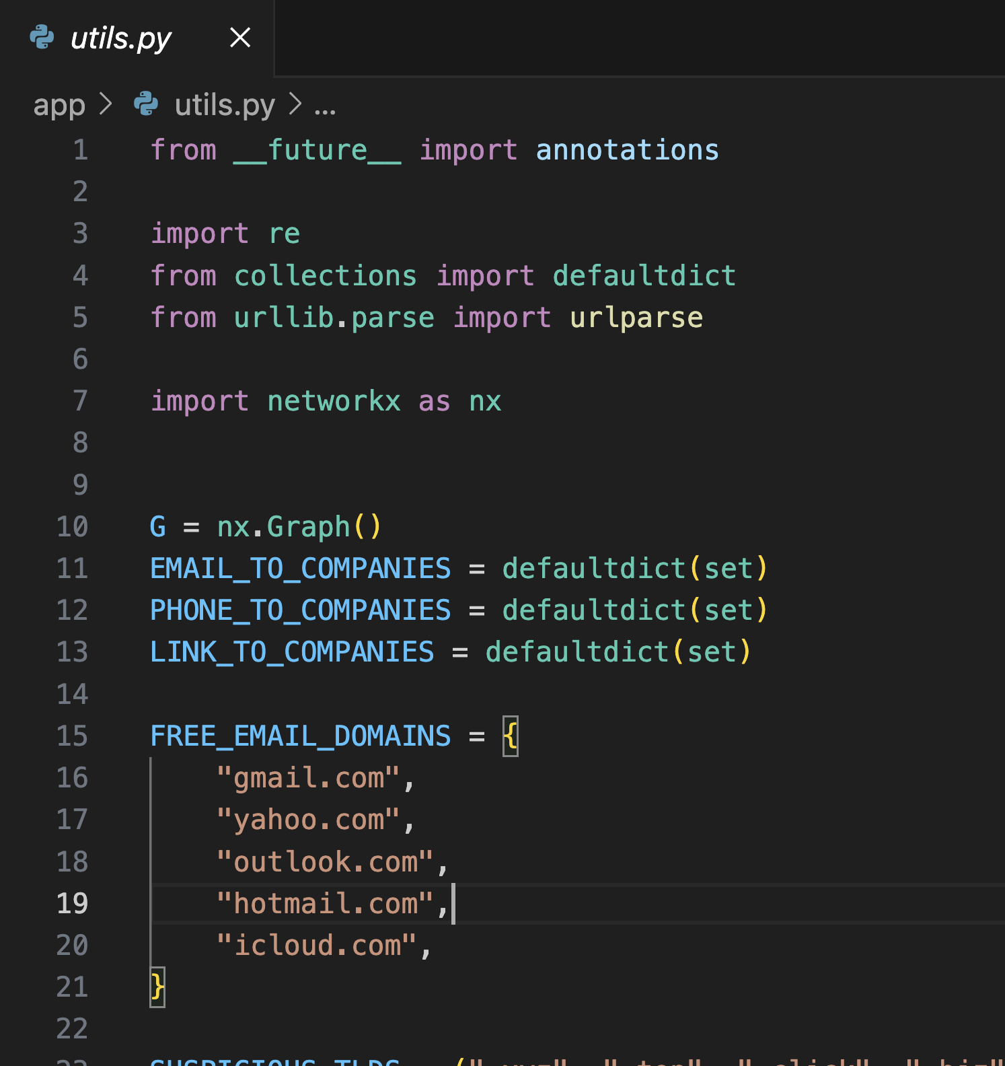
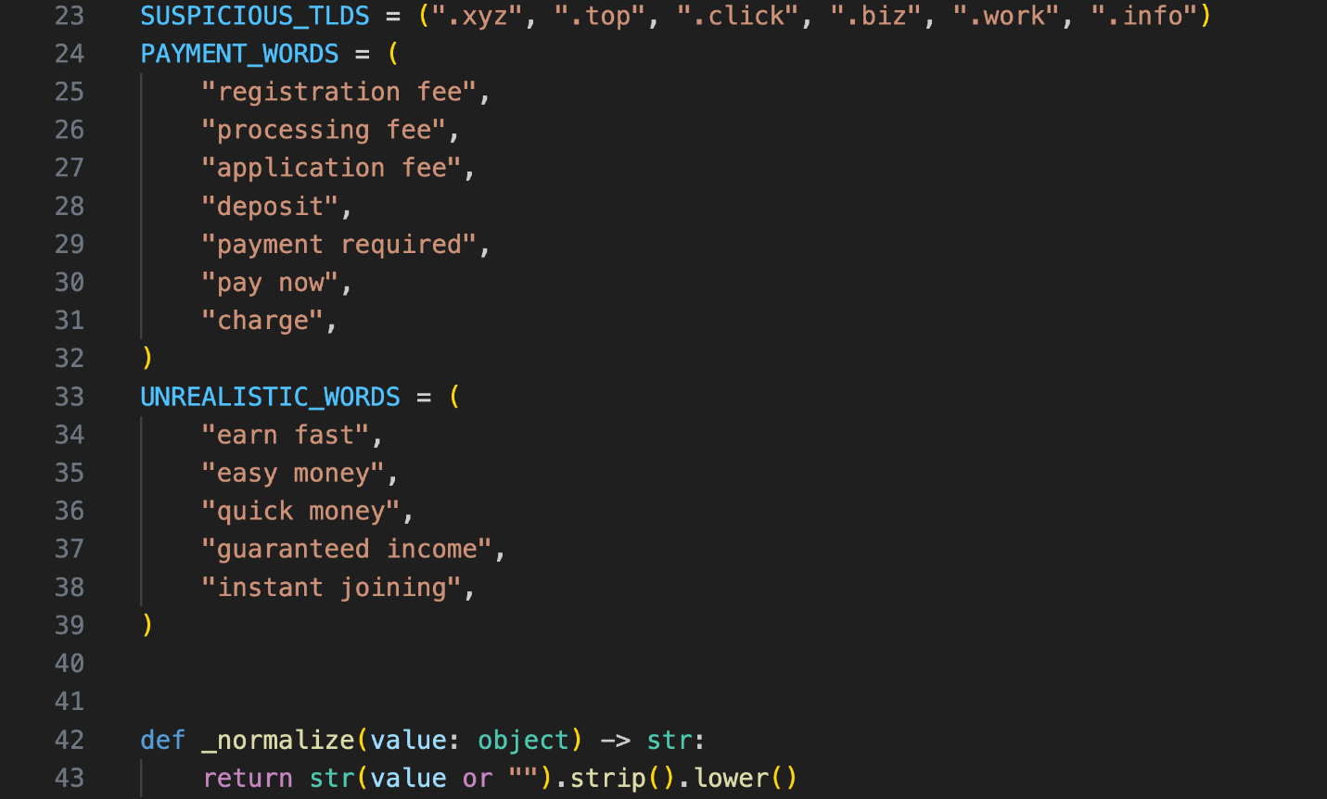
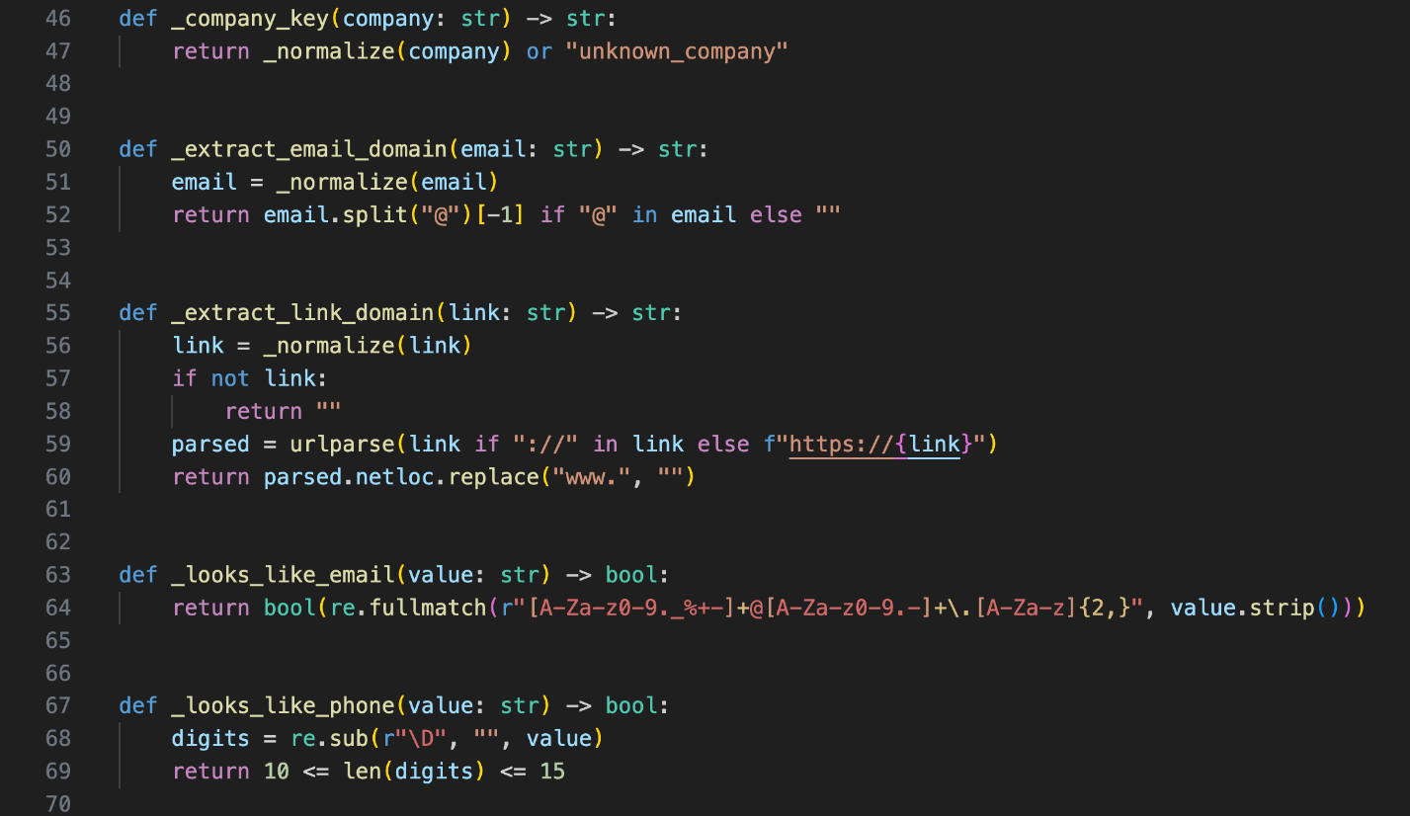
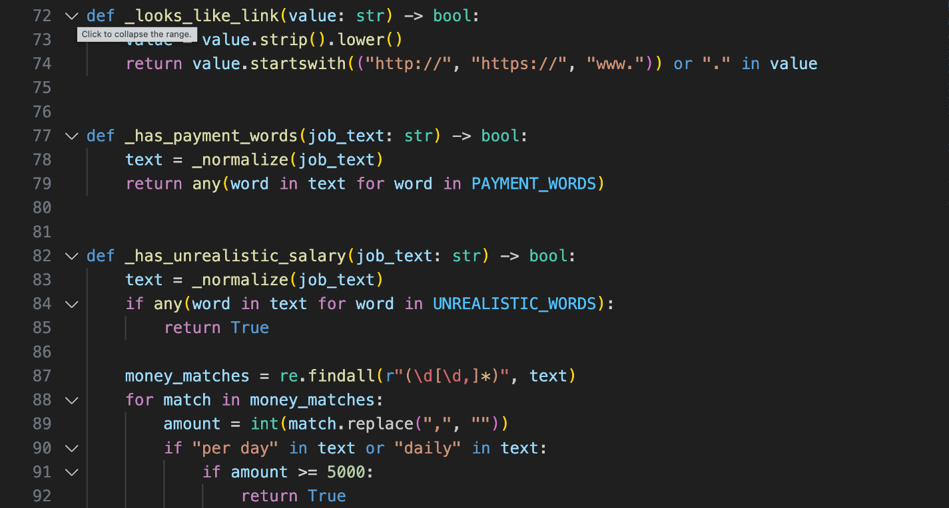
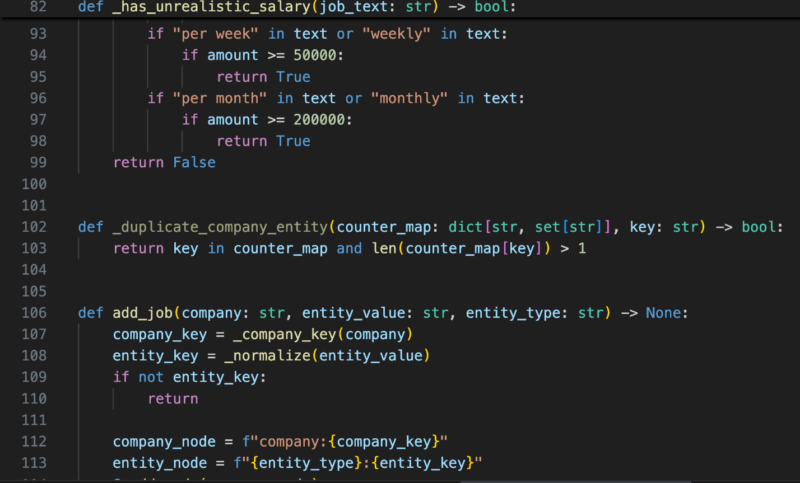
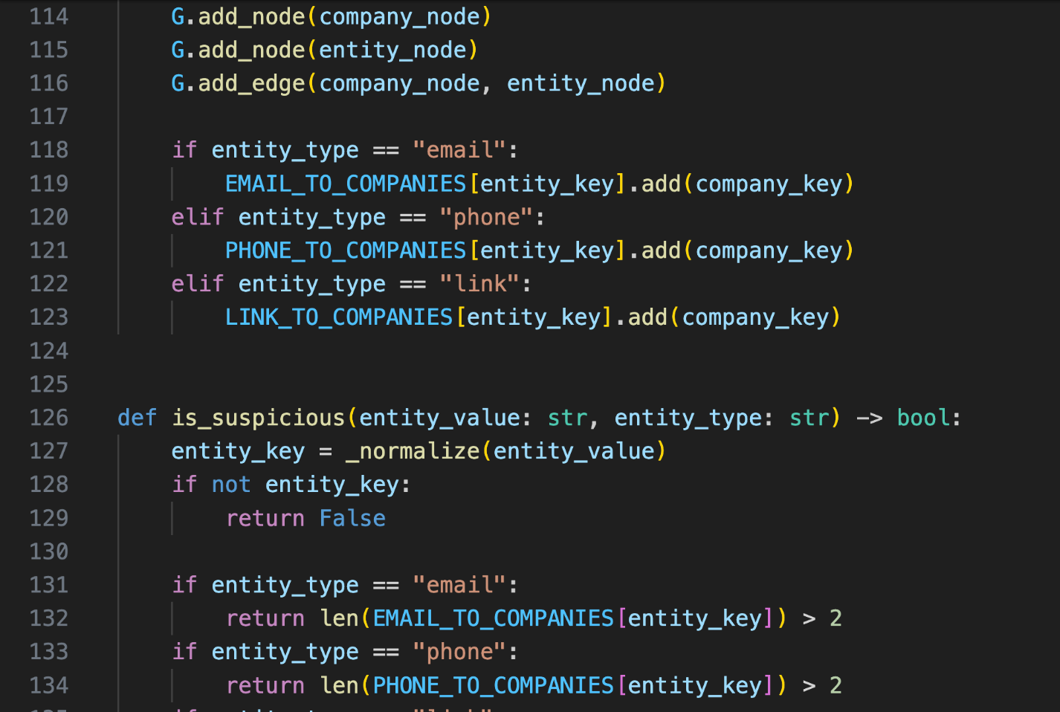
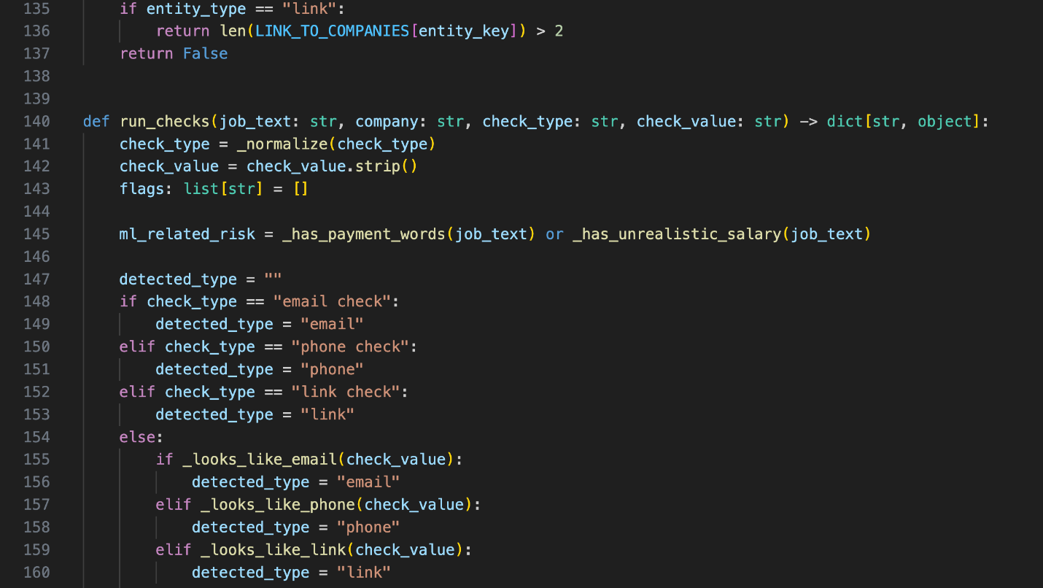
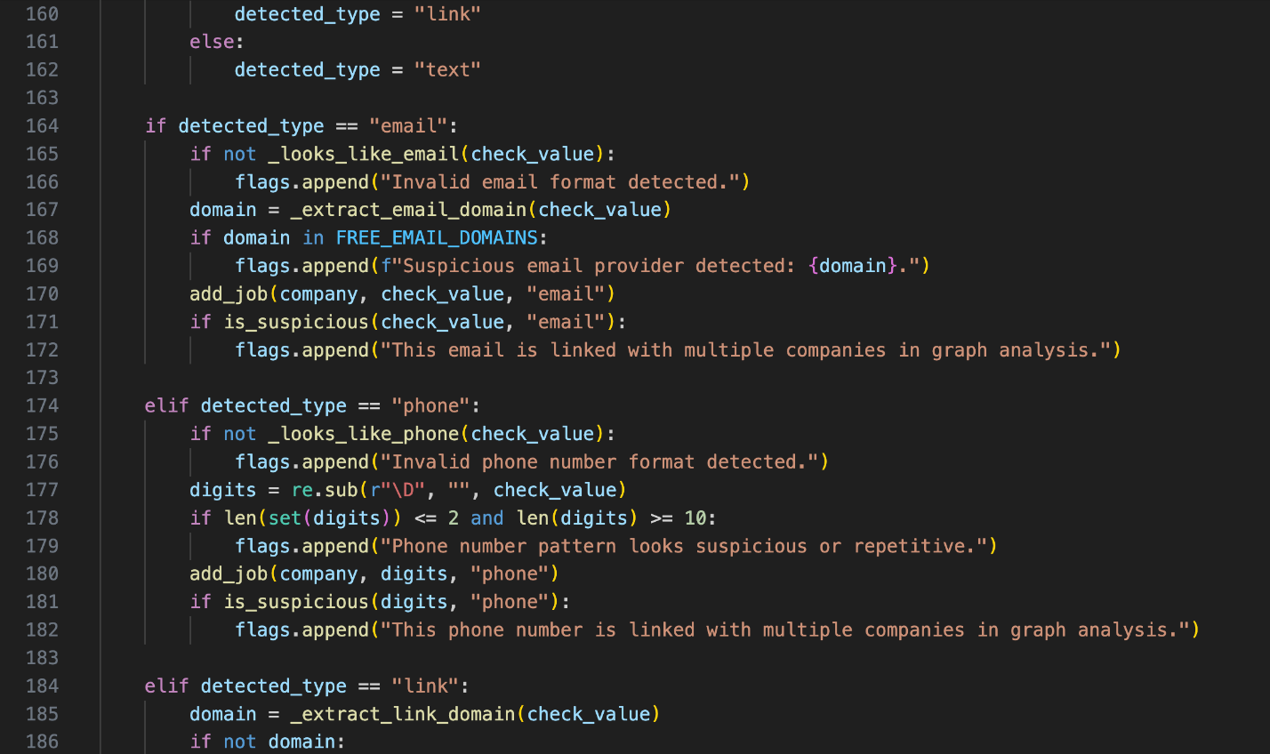
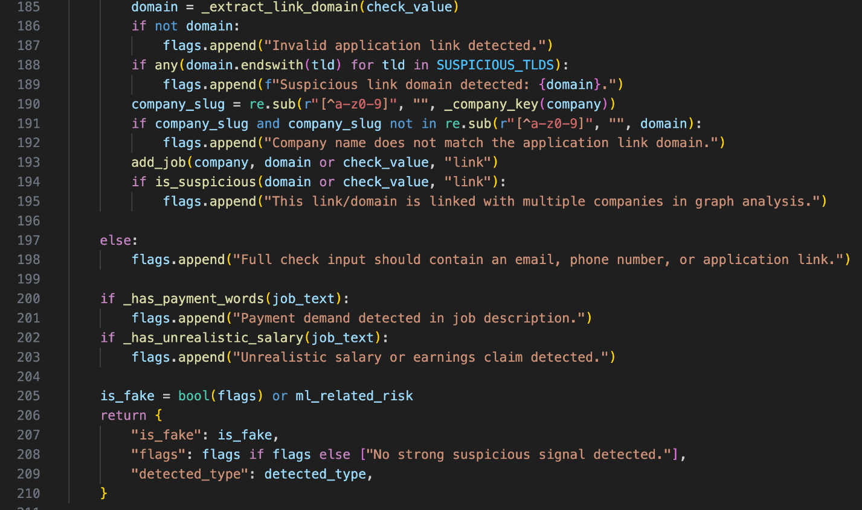

5.1.3) training.ipynb

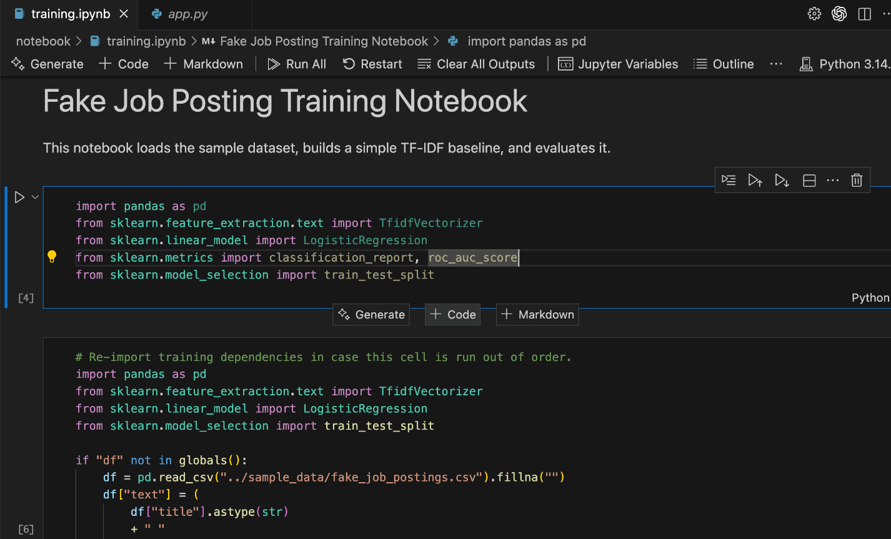
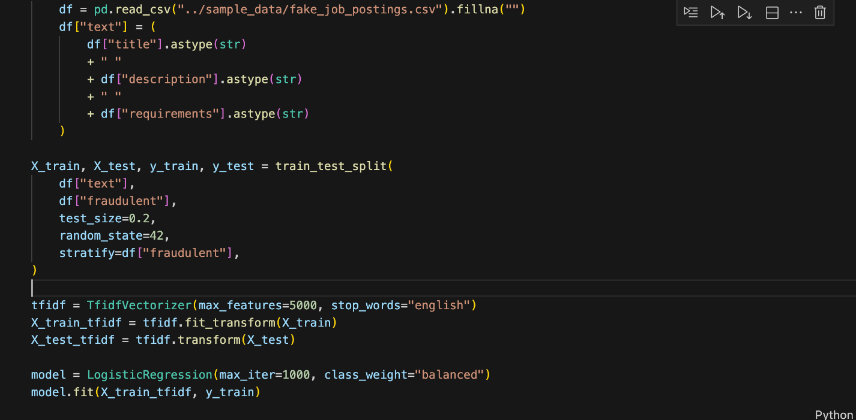
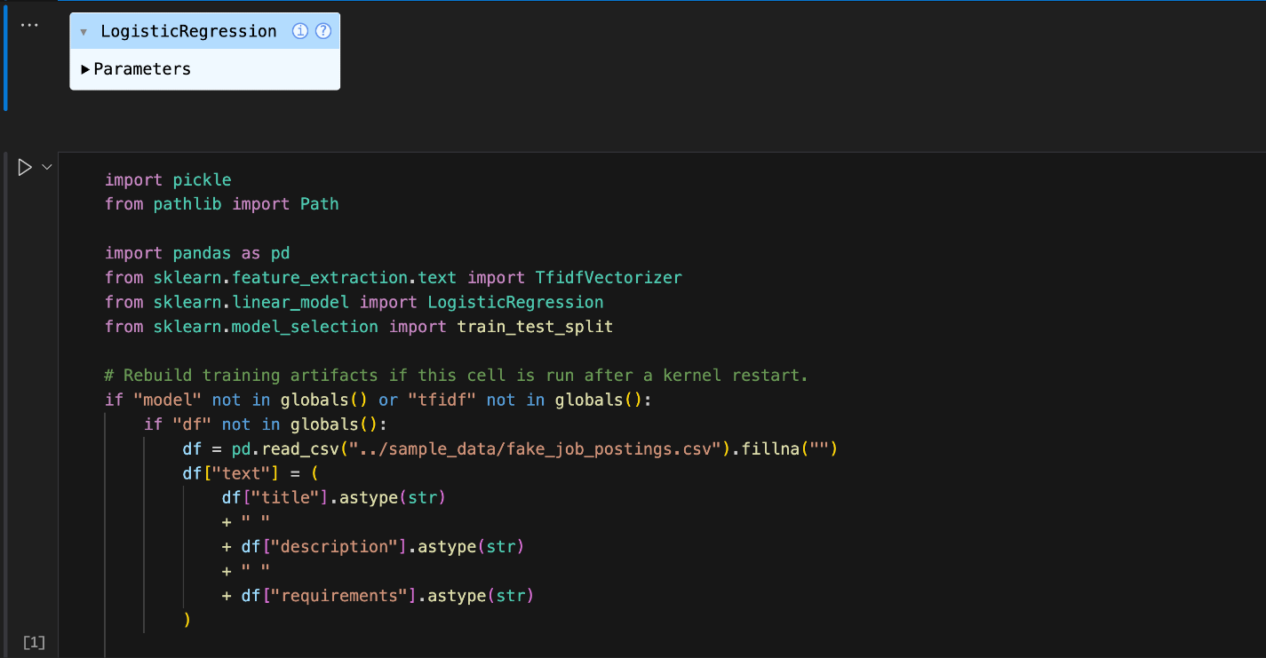
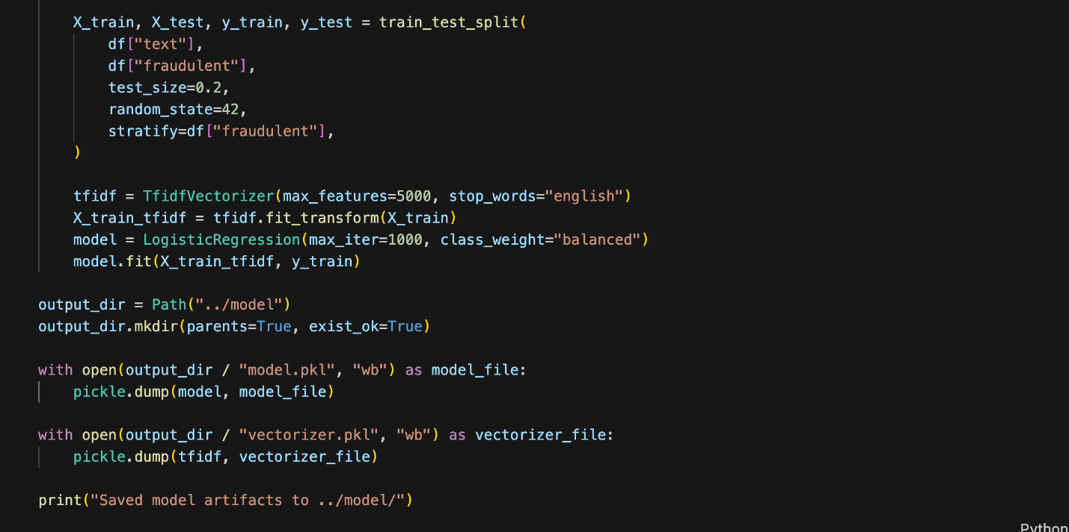
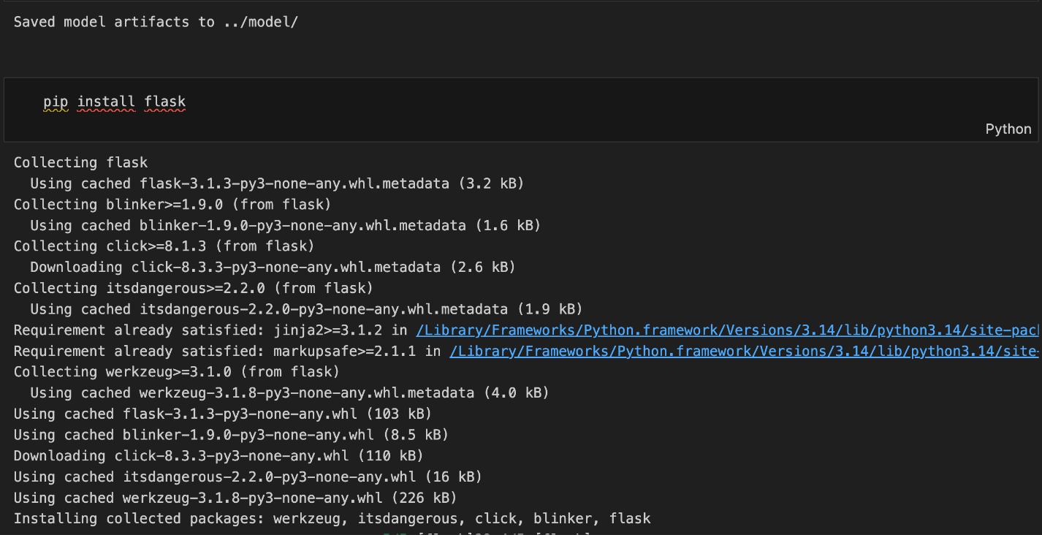

5.1.4) Folder
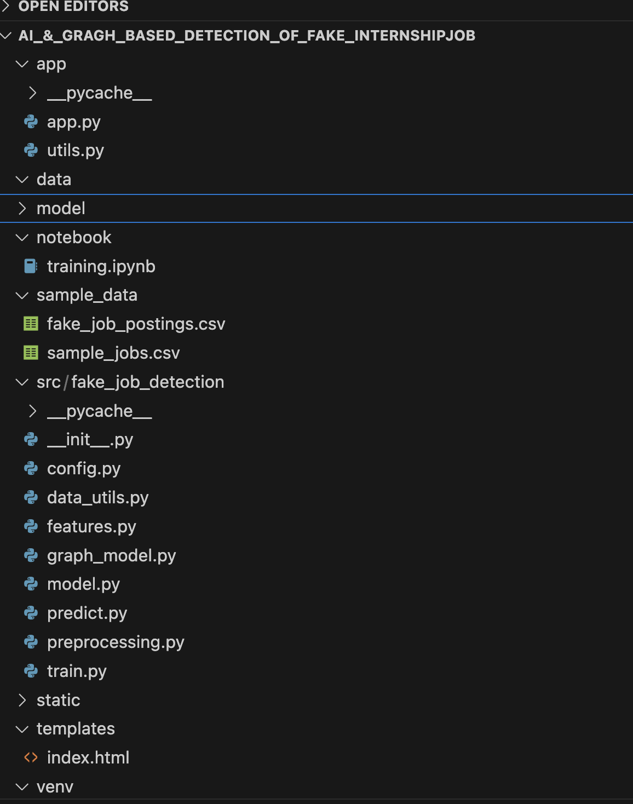
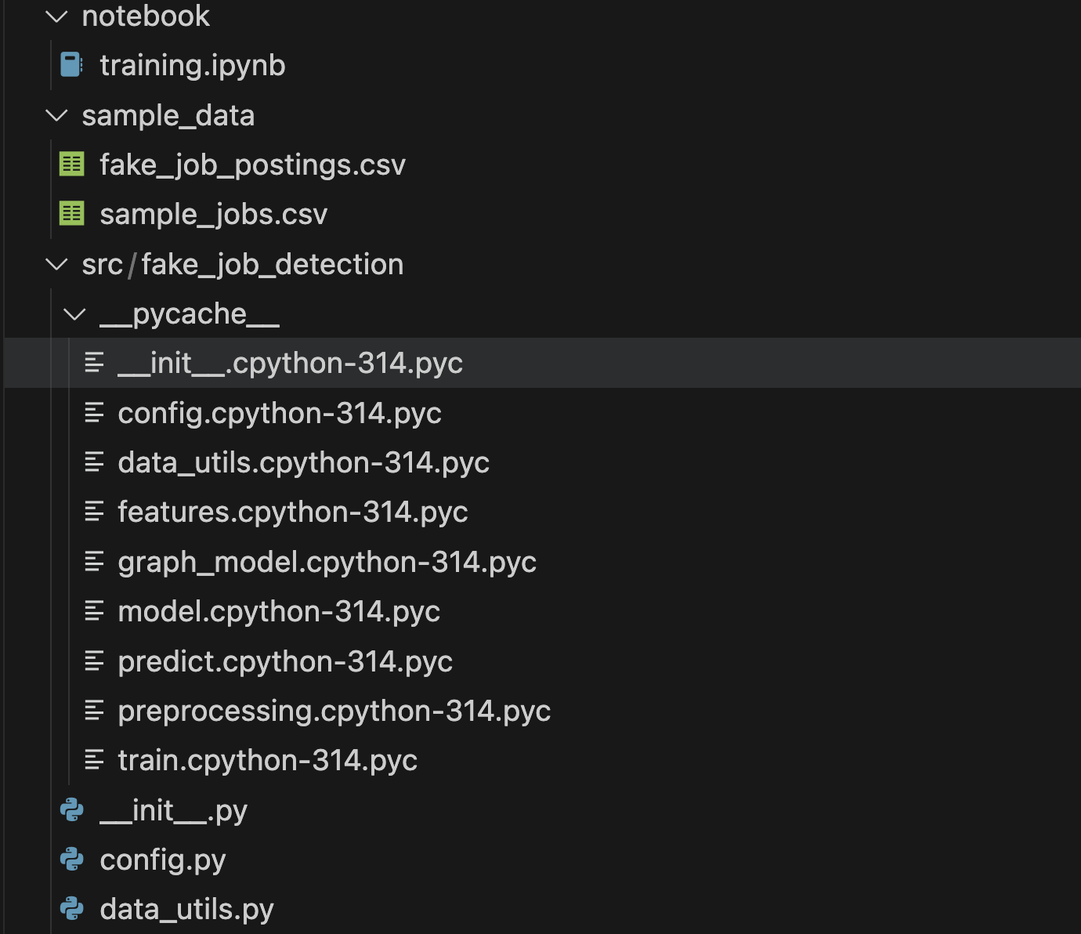
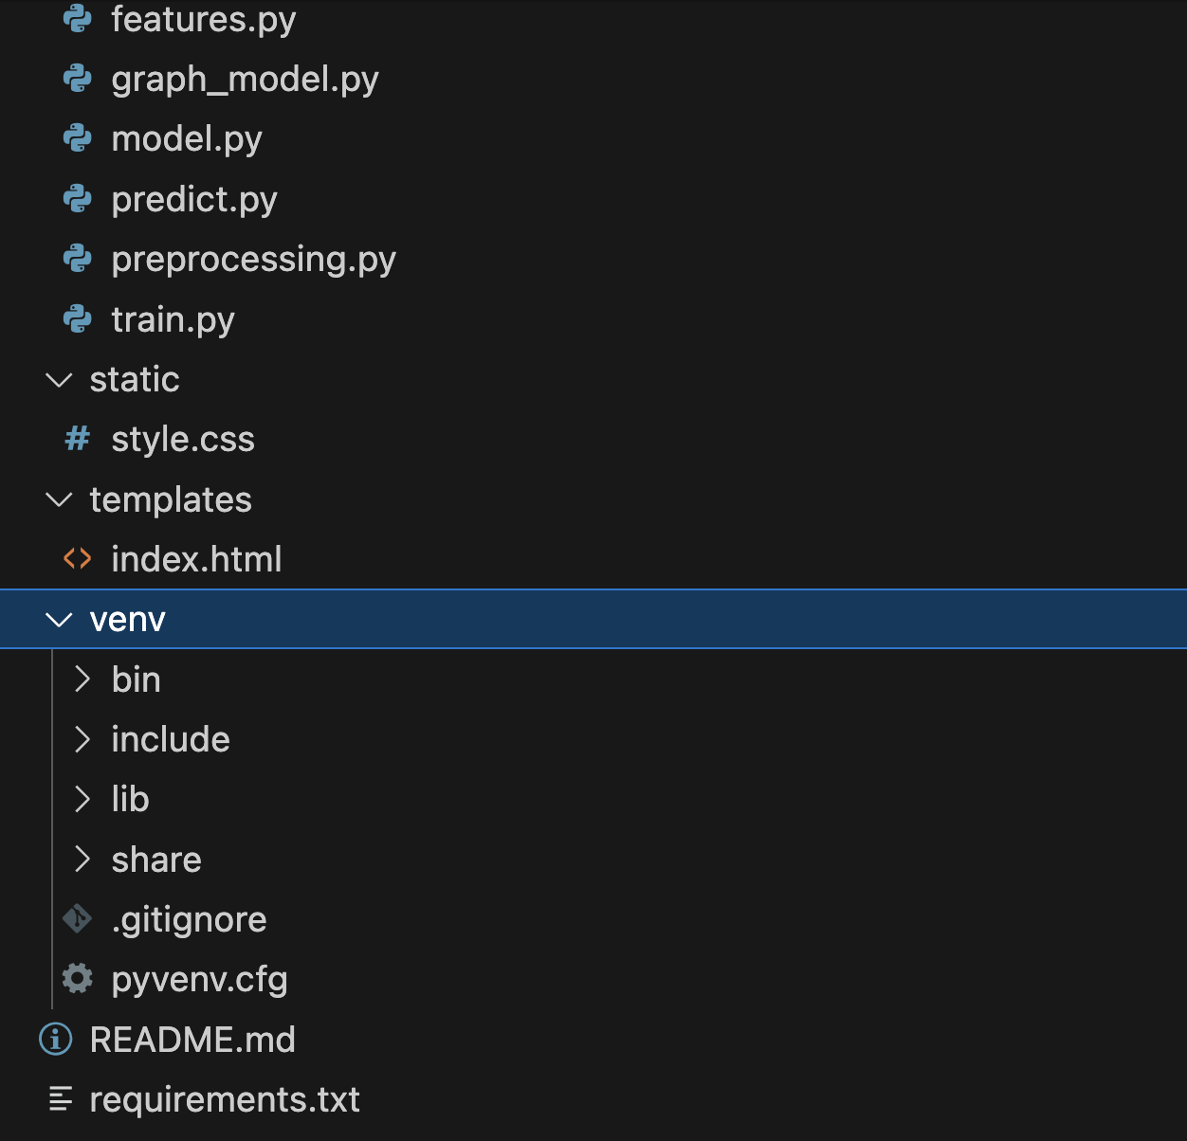

5.1.5) config.py
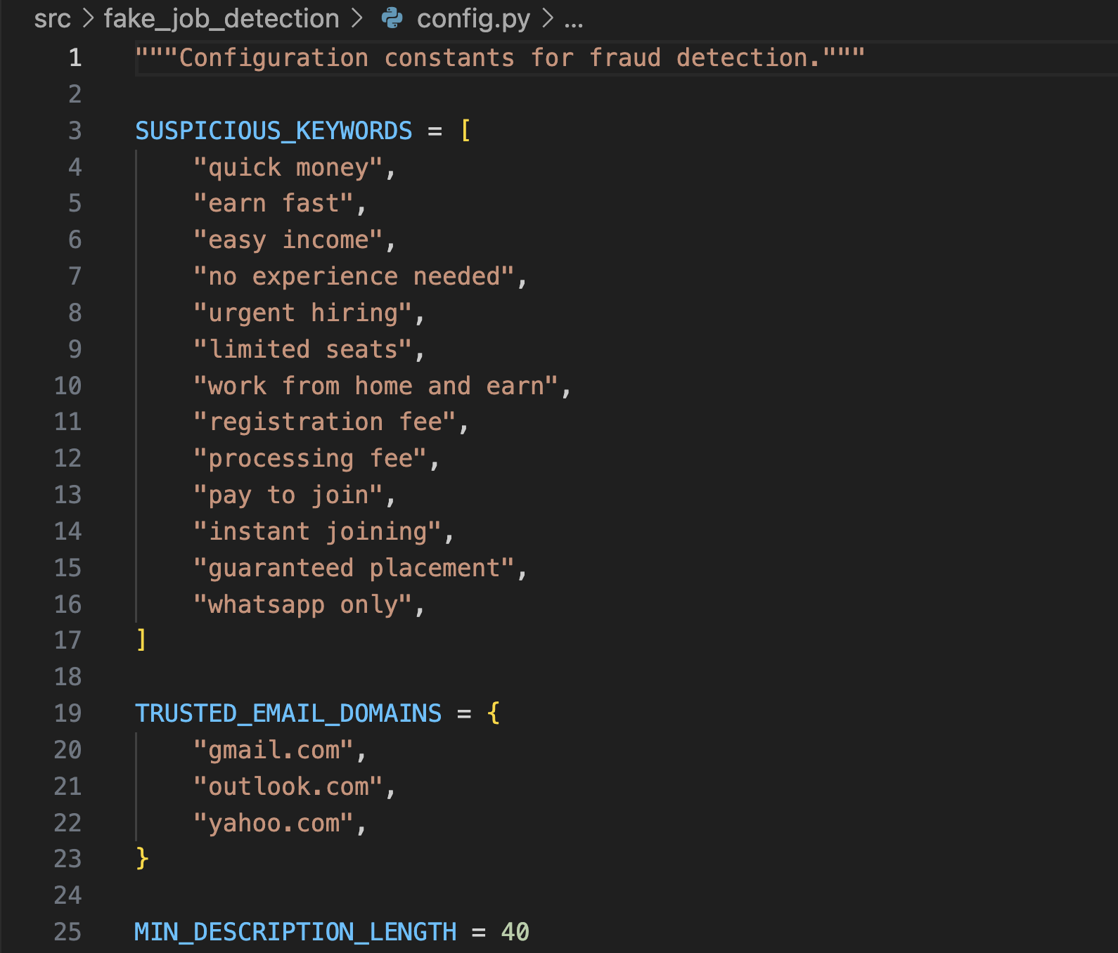

5.1.6) data_utils.py
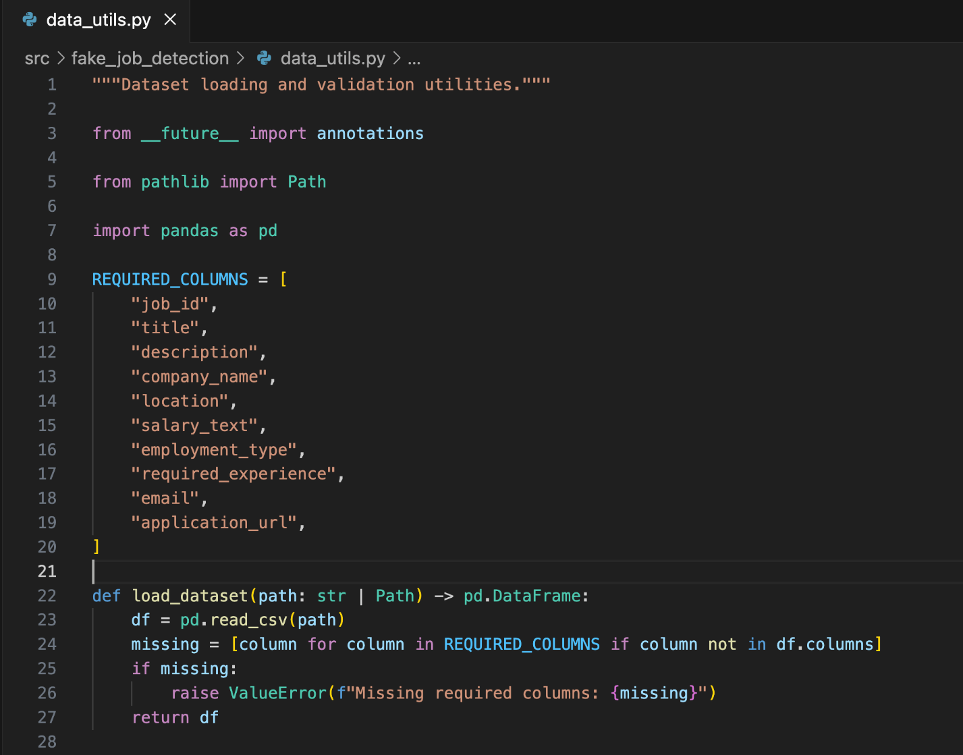

5.1.7) features.py
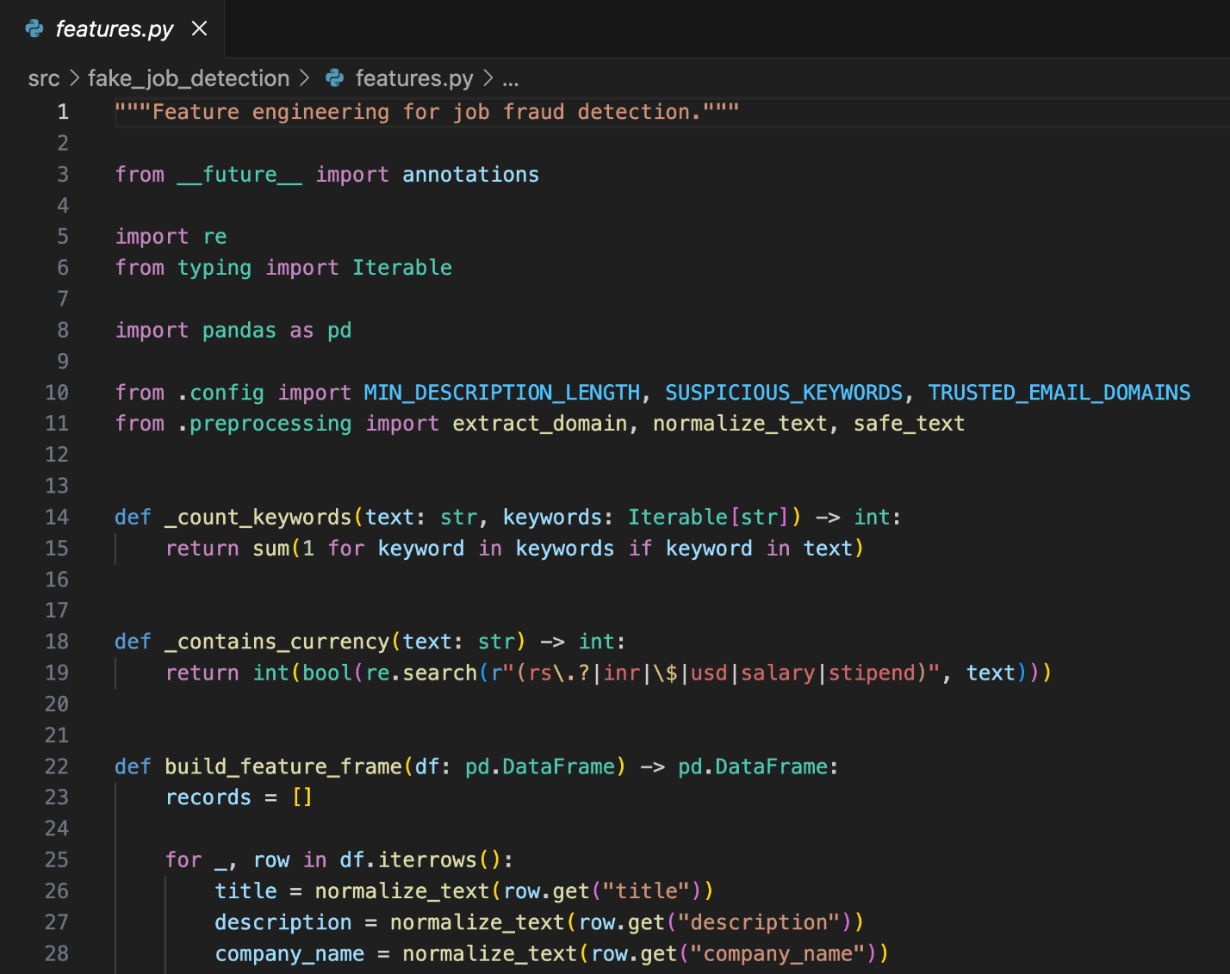
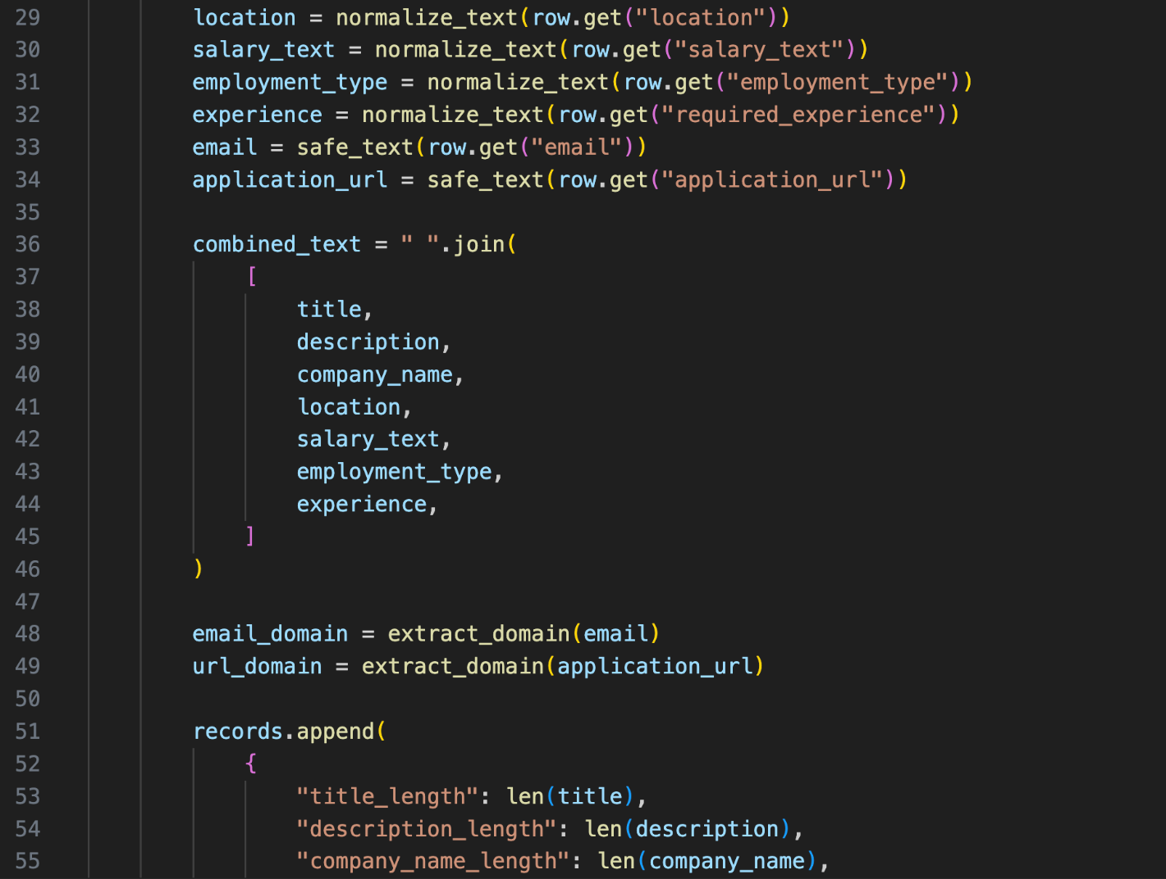
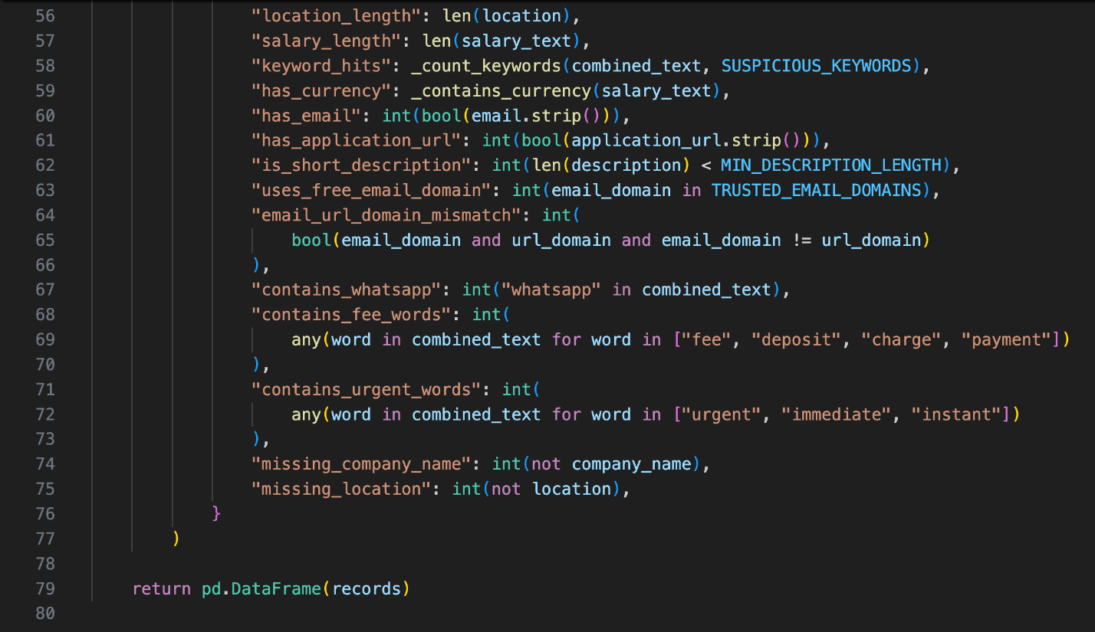

5.1.8) graph_model.py
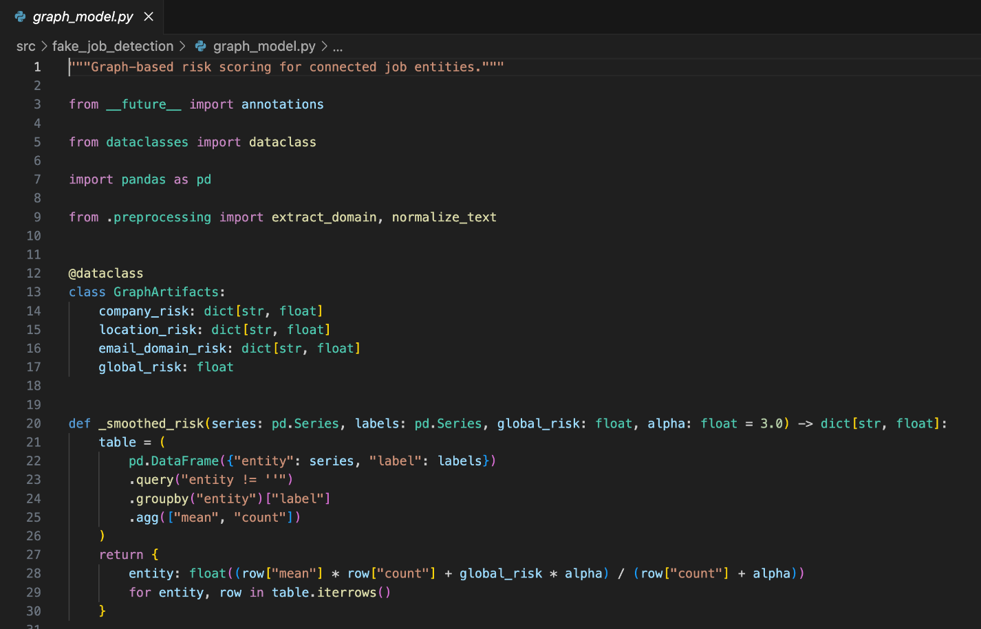
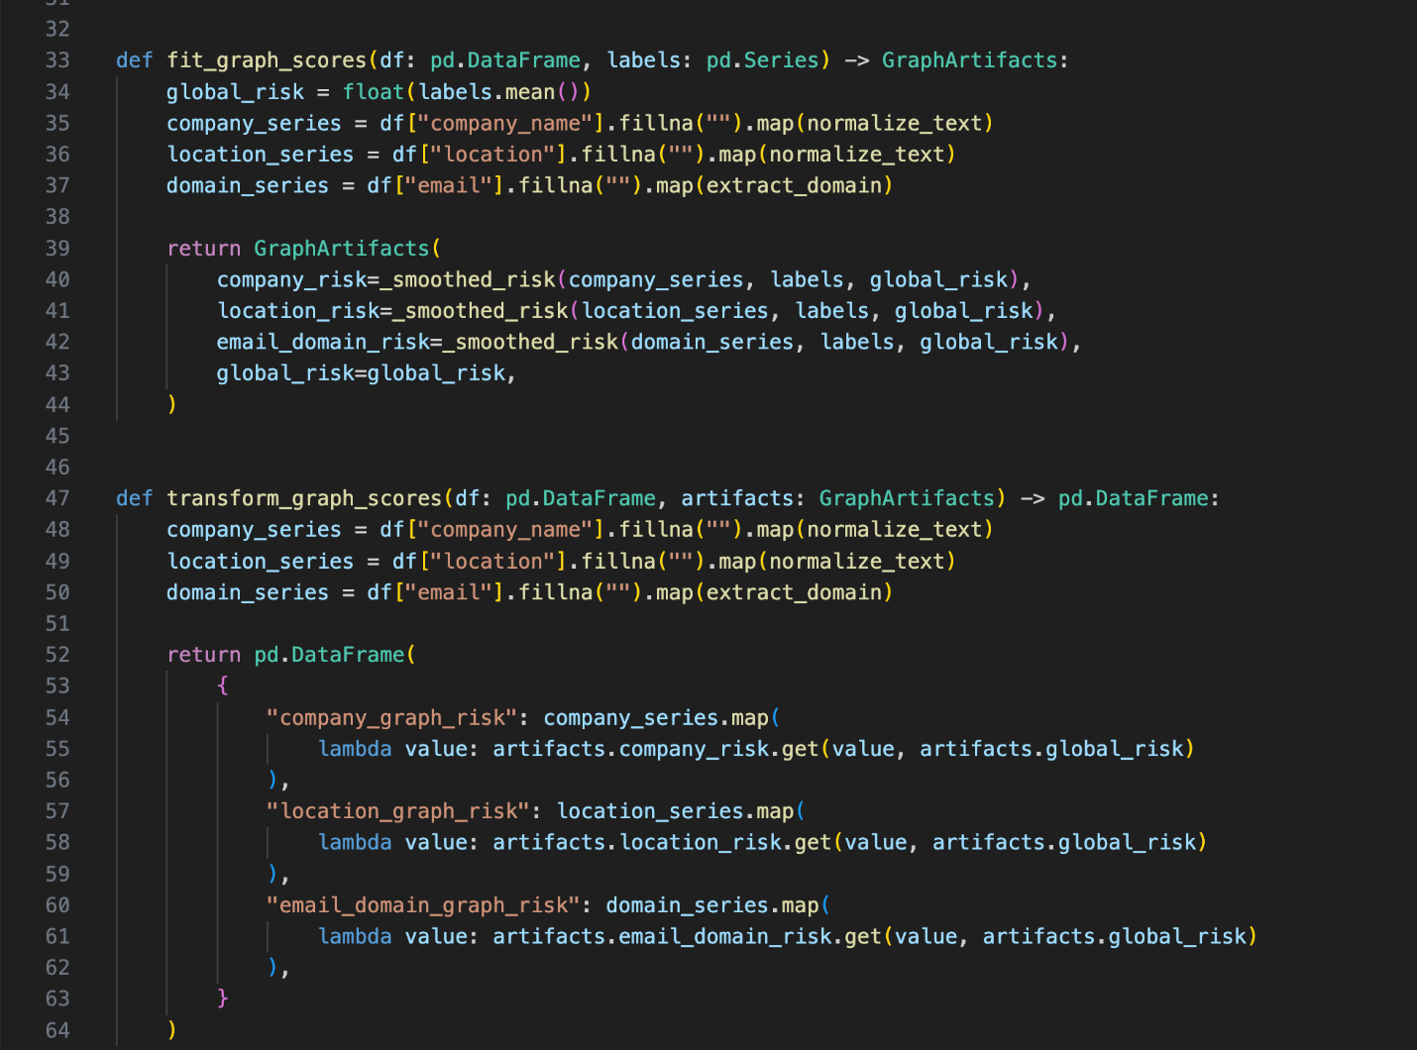

5.1.9) model.py
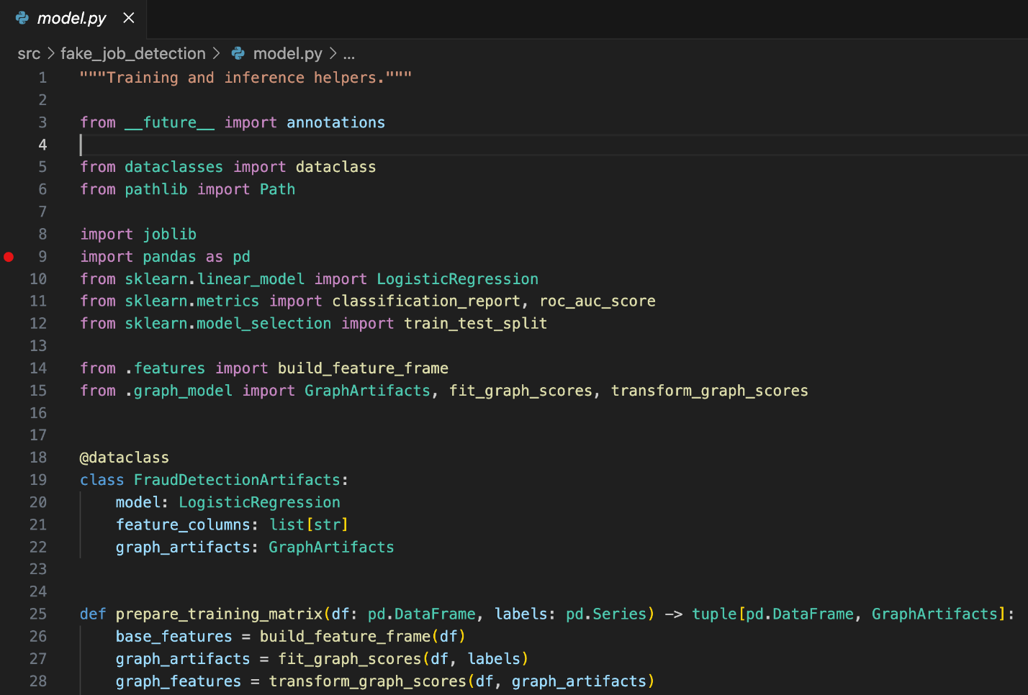
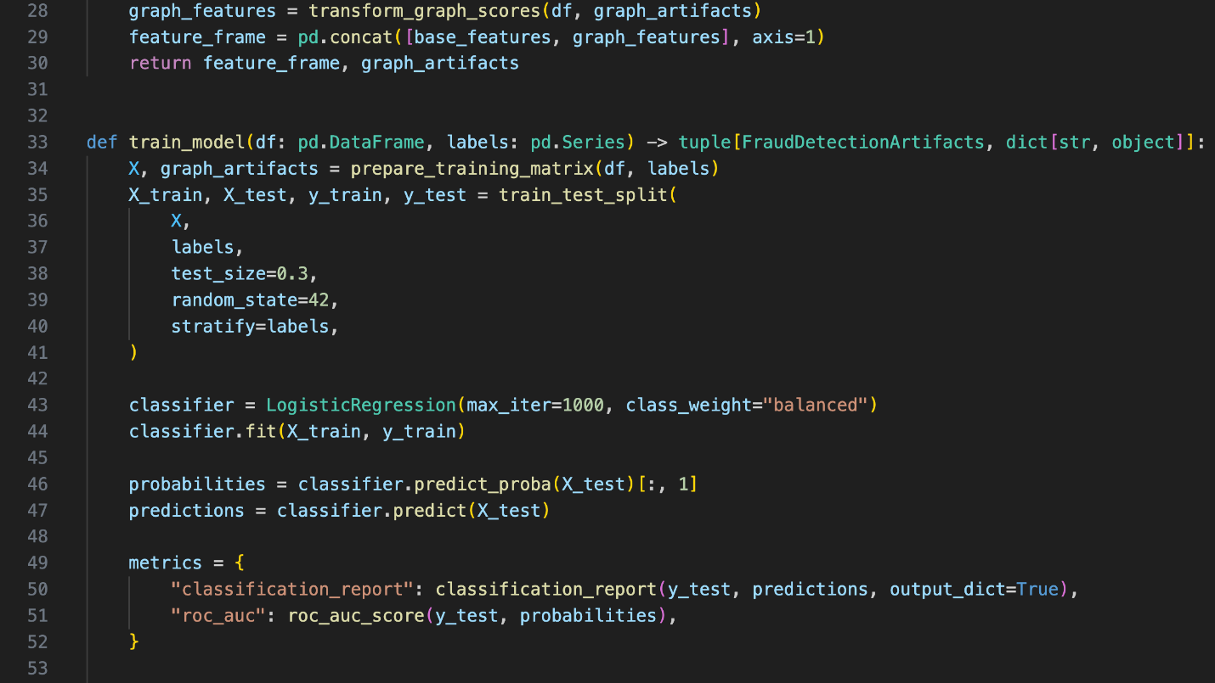
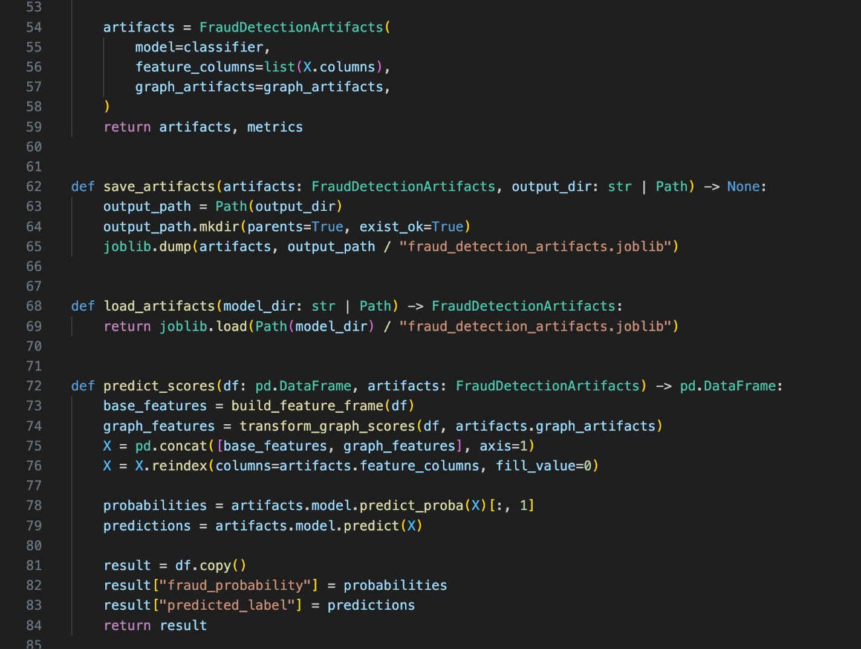

5.1.10) predict.py
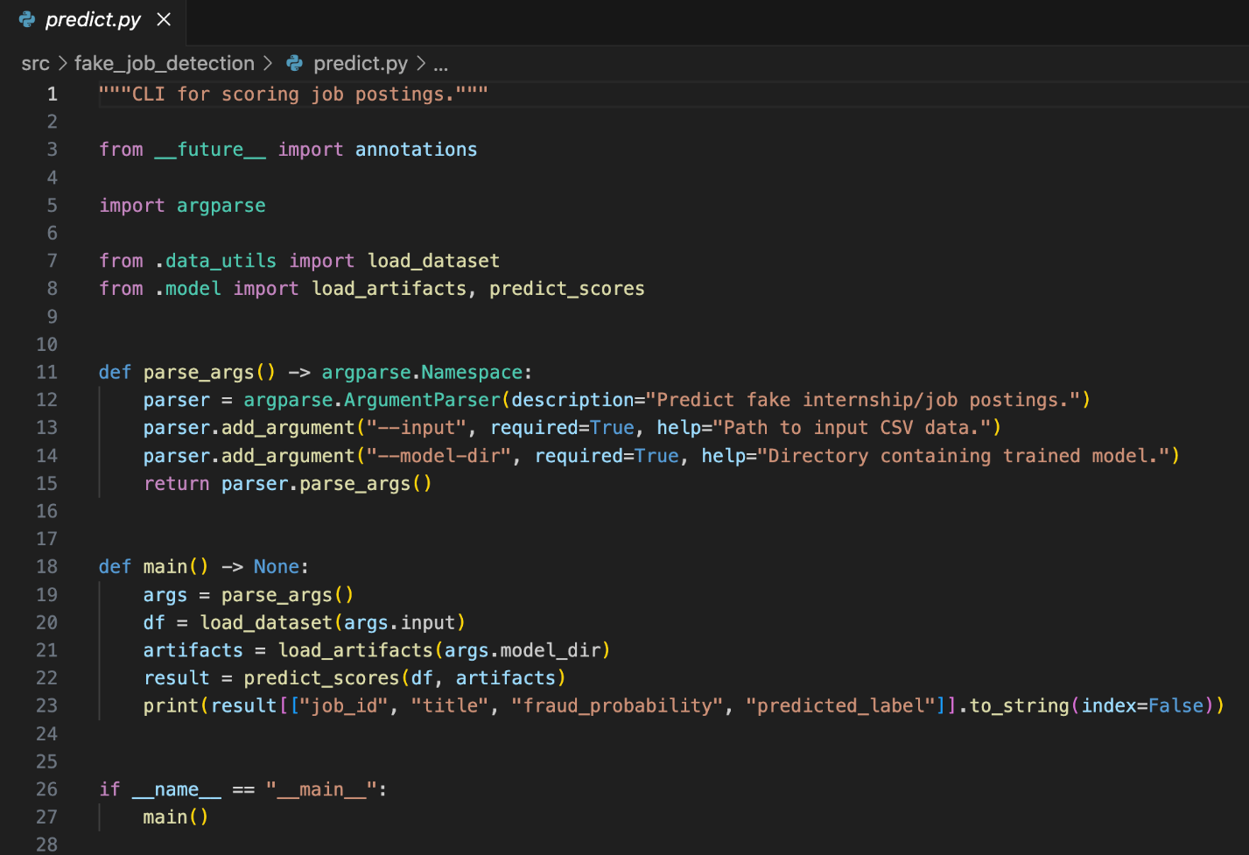

5.1.11) preprocessing.py
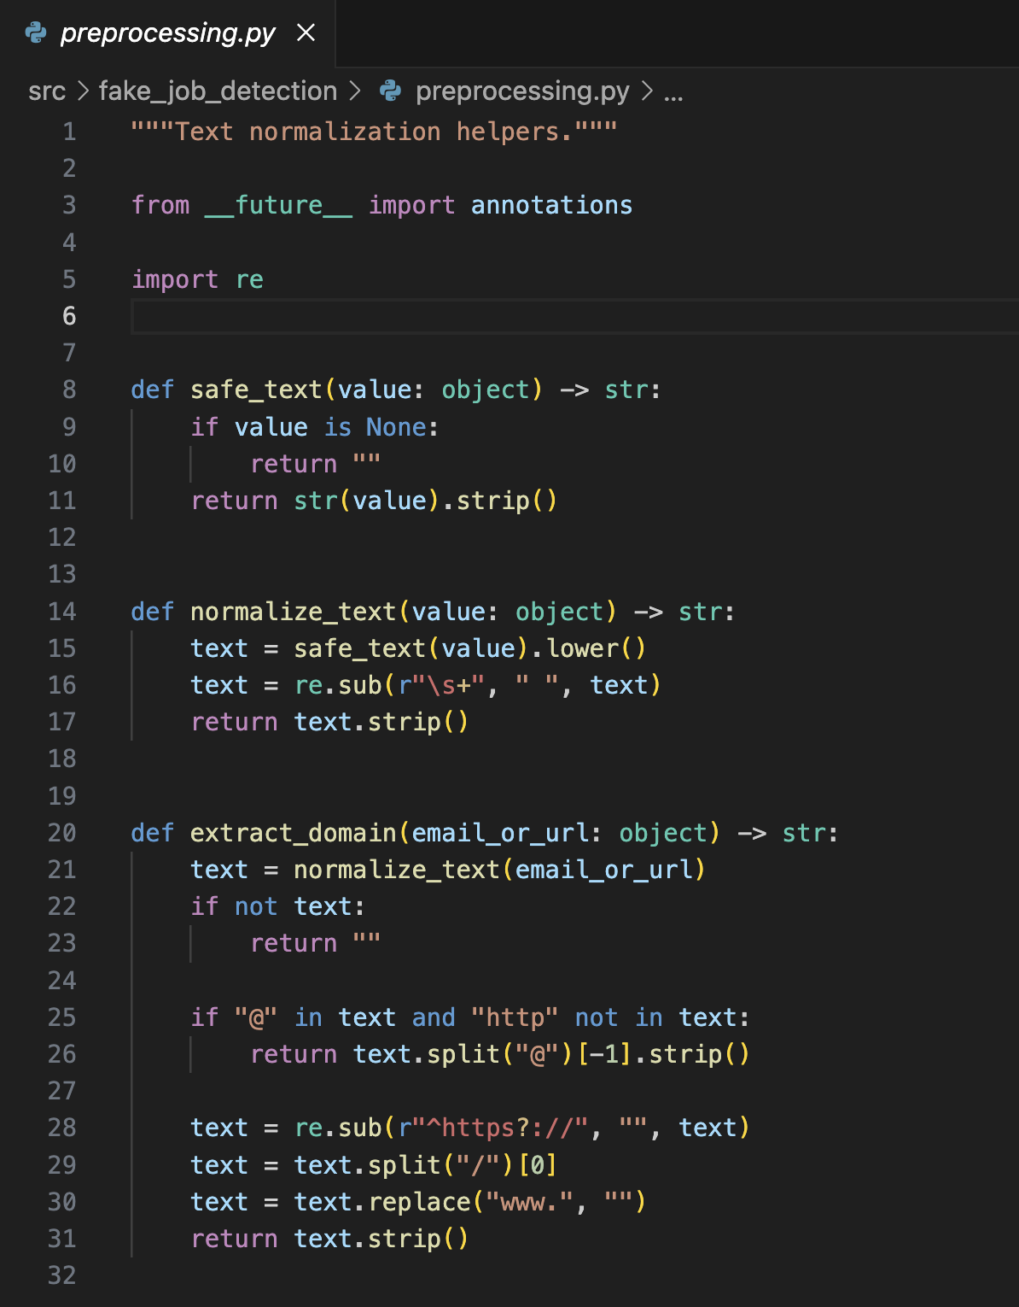

5.1.12) train.py
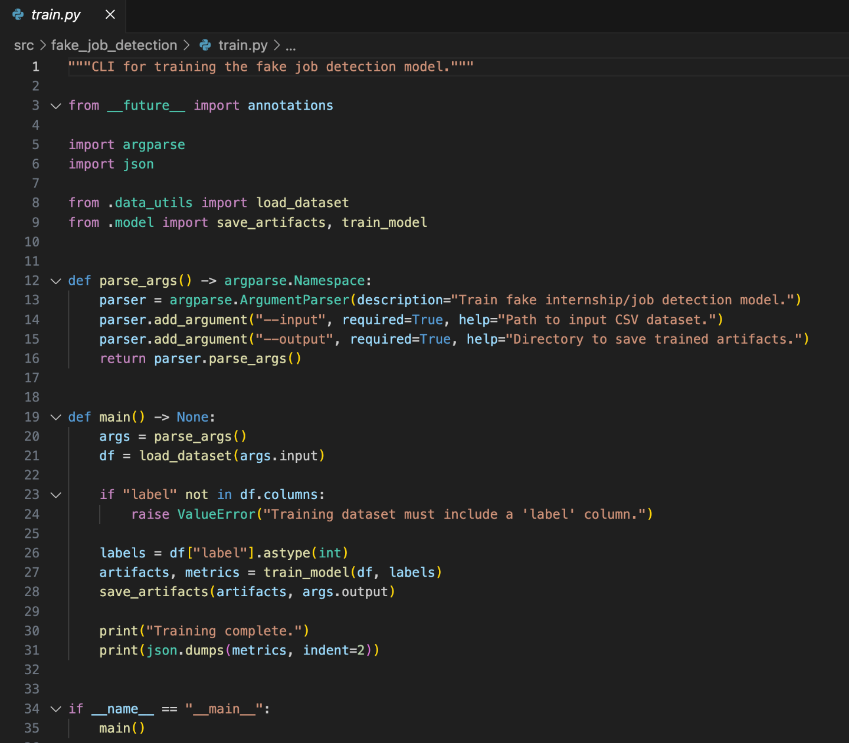

5.1.13) style.css
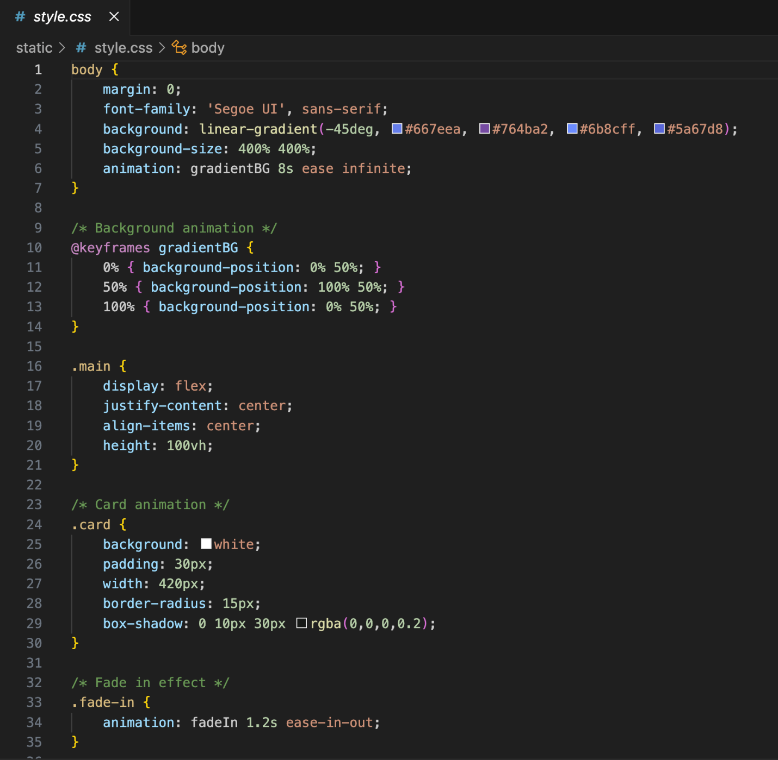


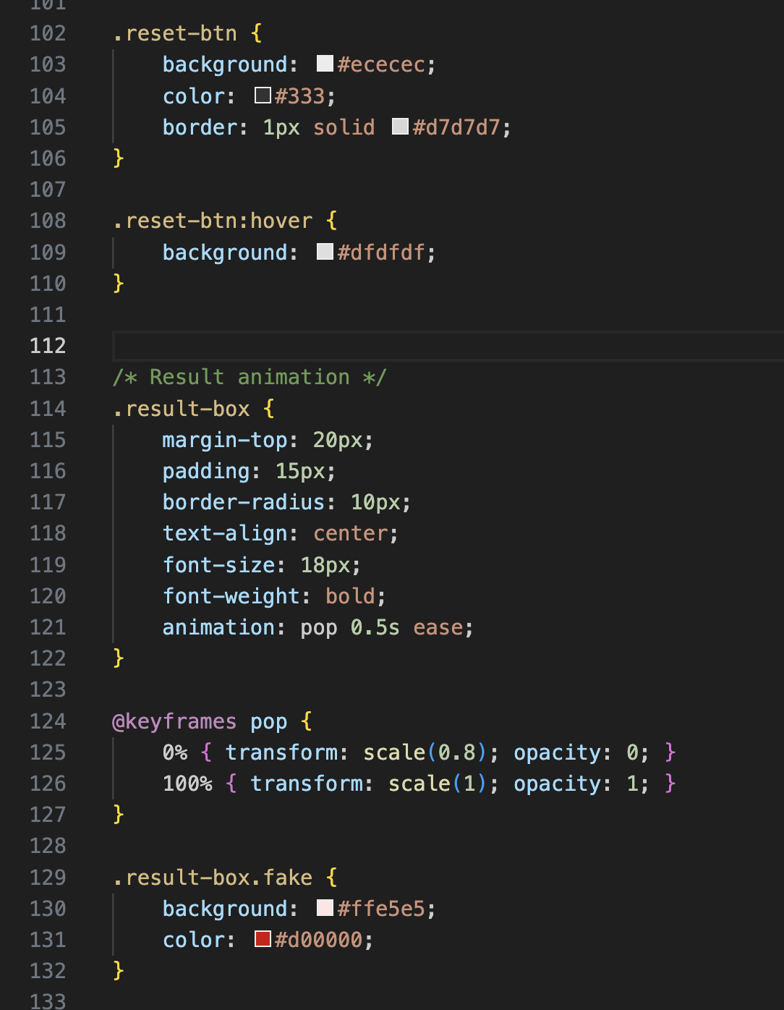


5.1.14) index.html
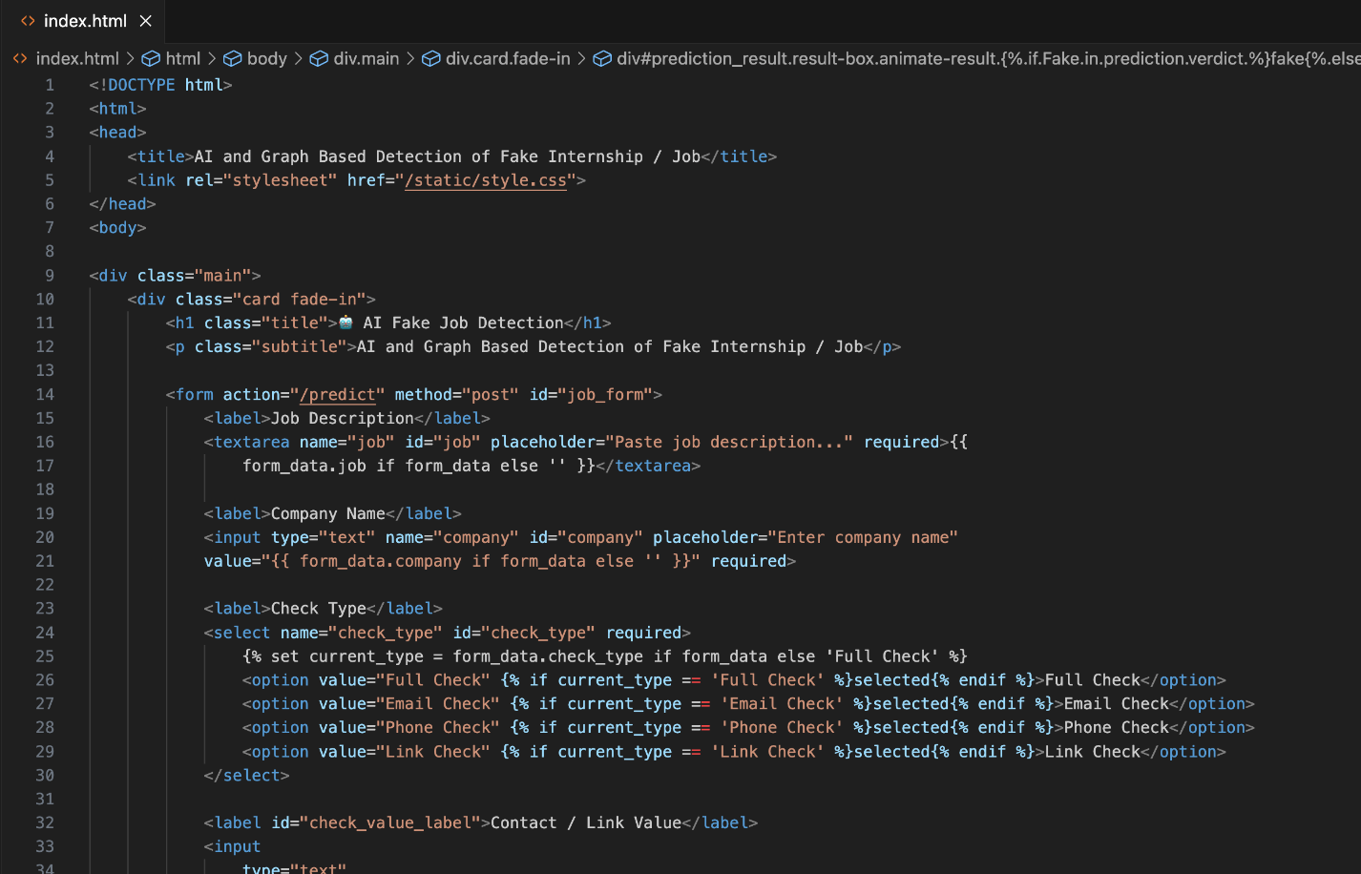
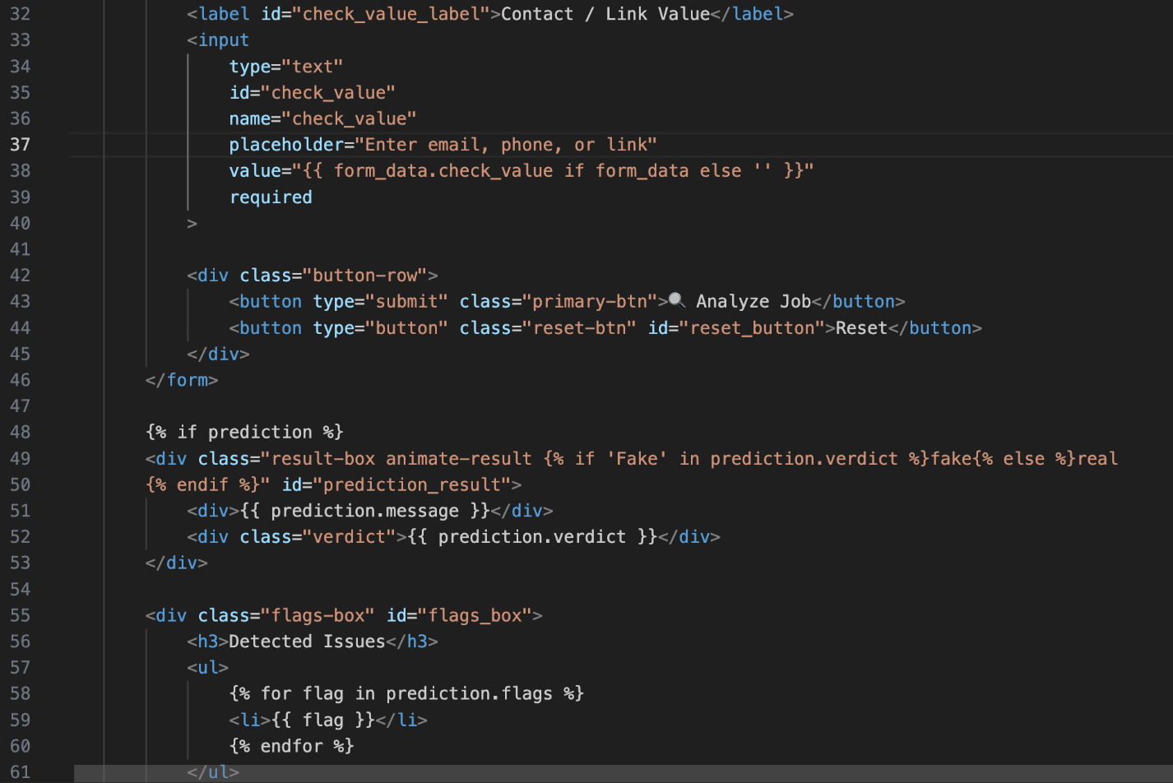
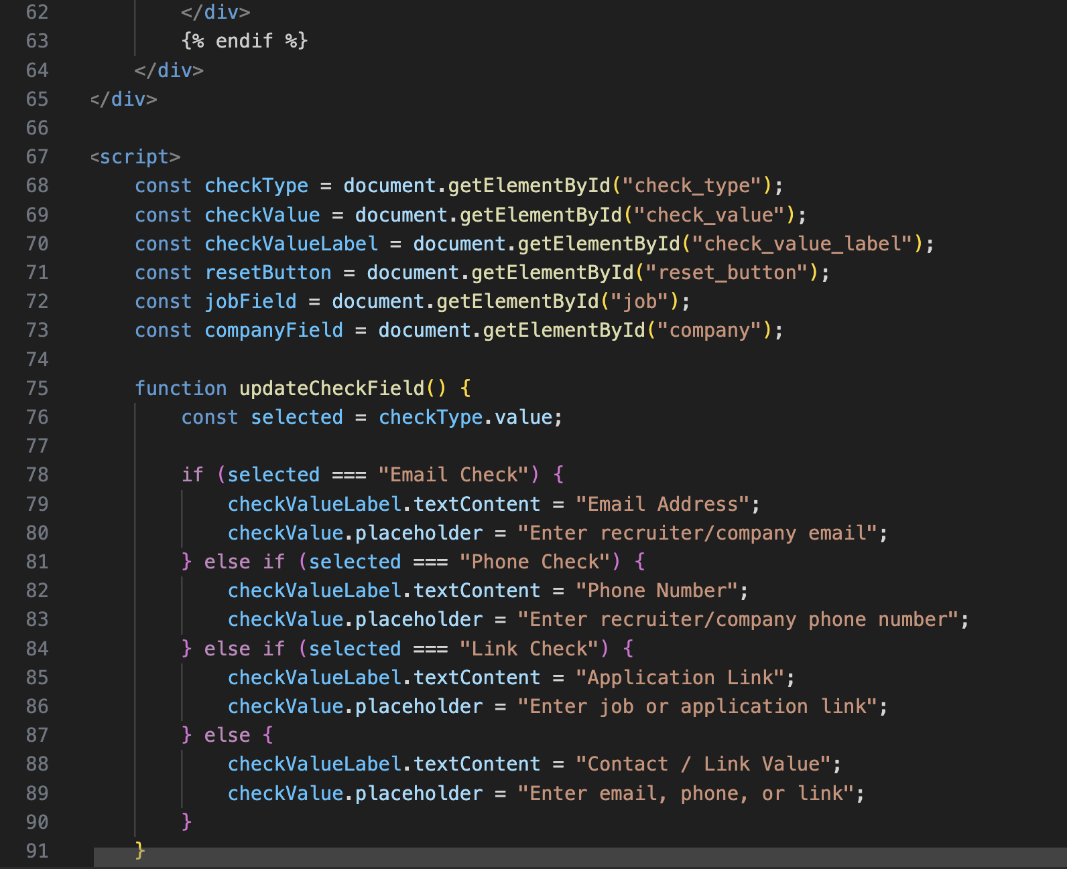
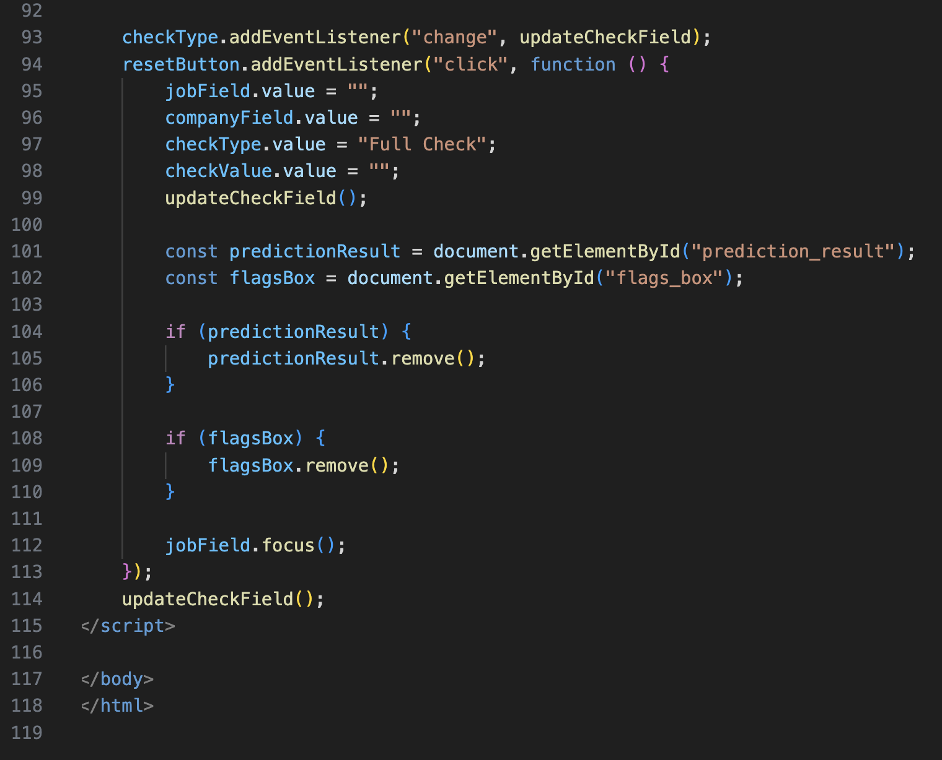

5.2 OUTPUT

5.2.1) Dashboard 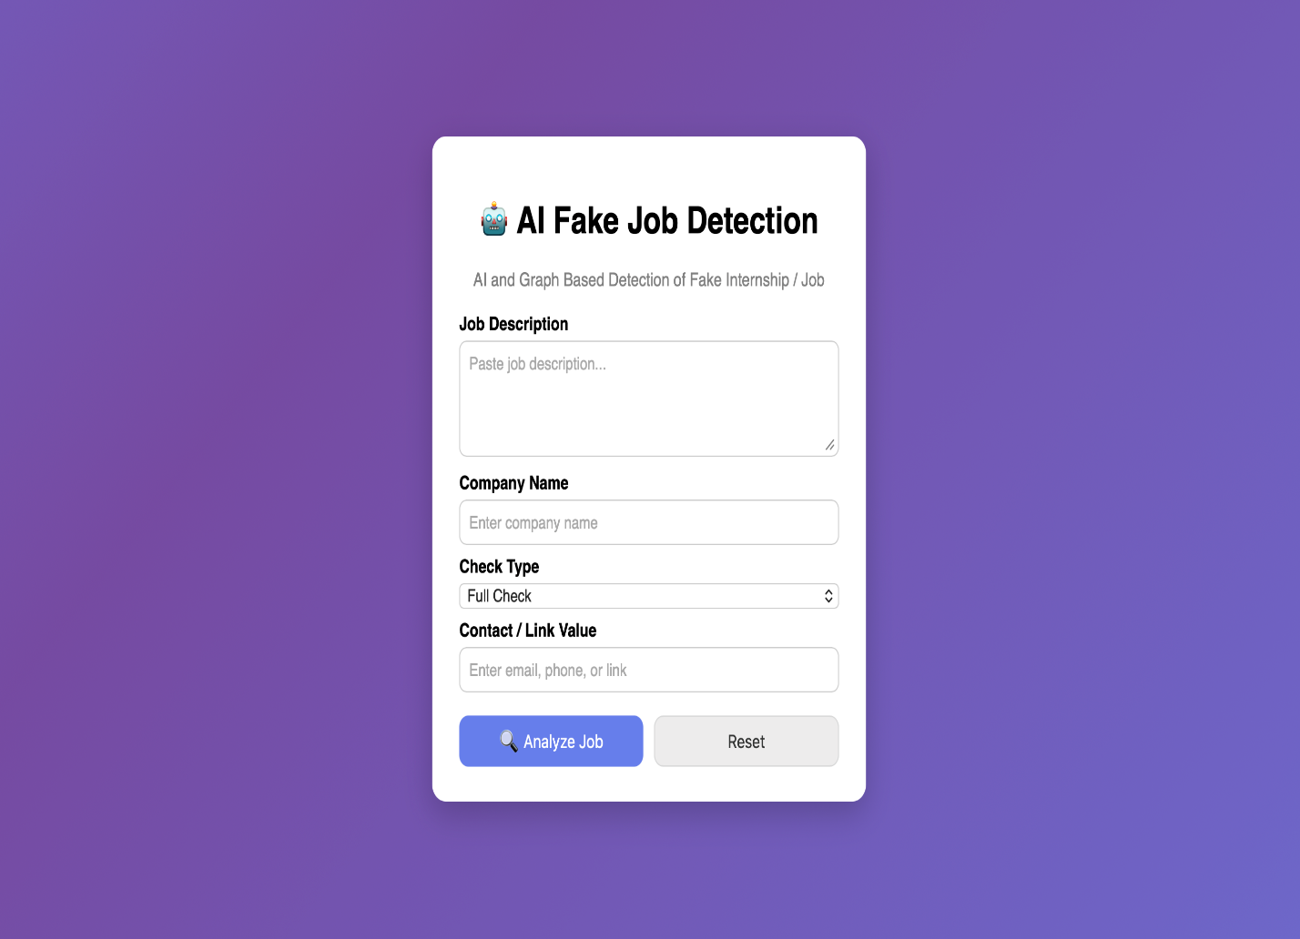
5.2.2) Result1
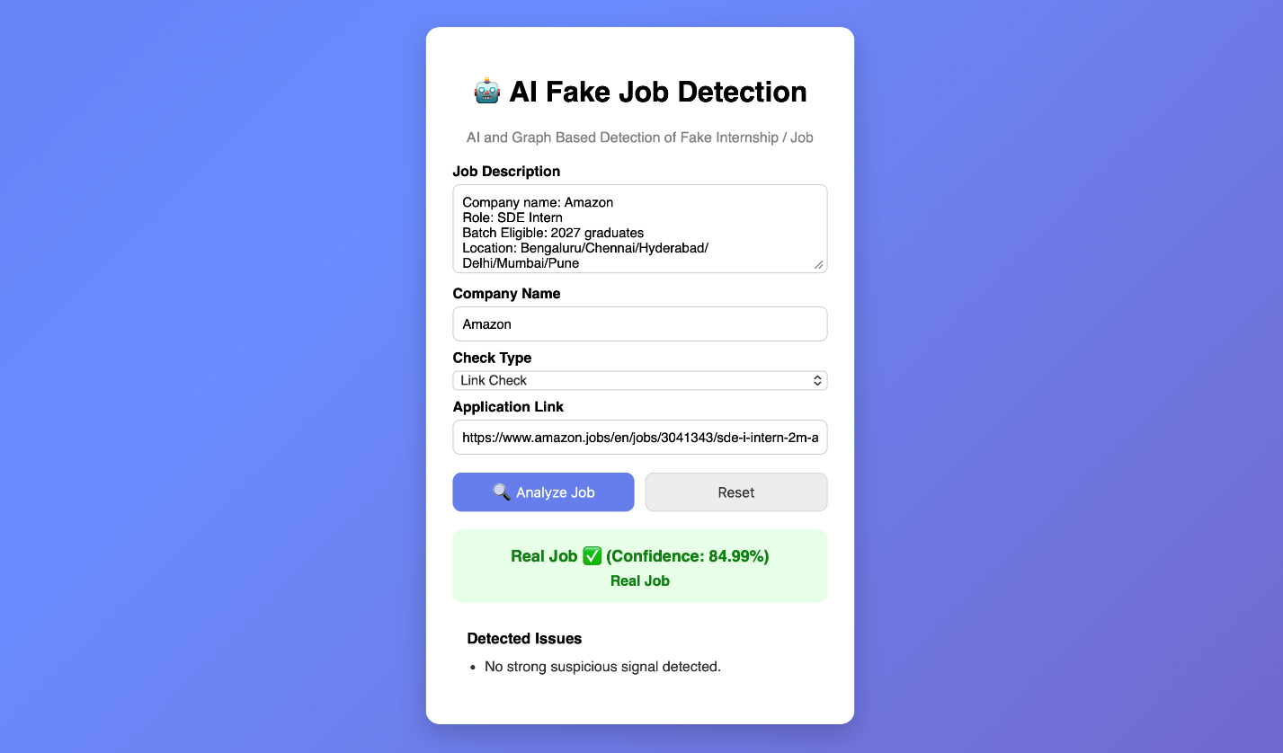
5.2.3) Result2

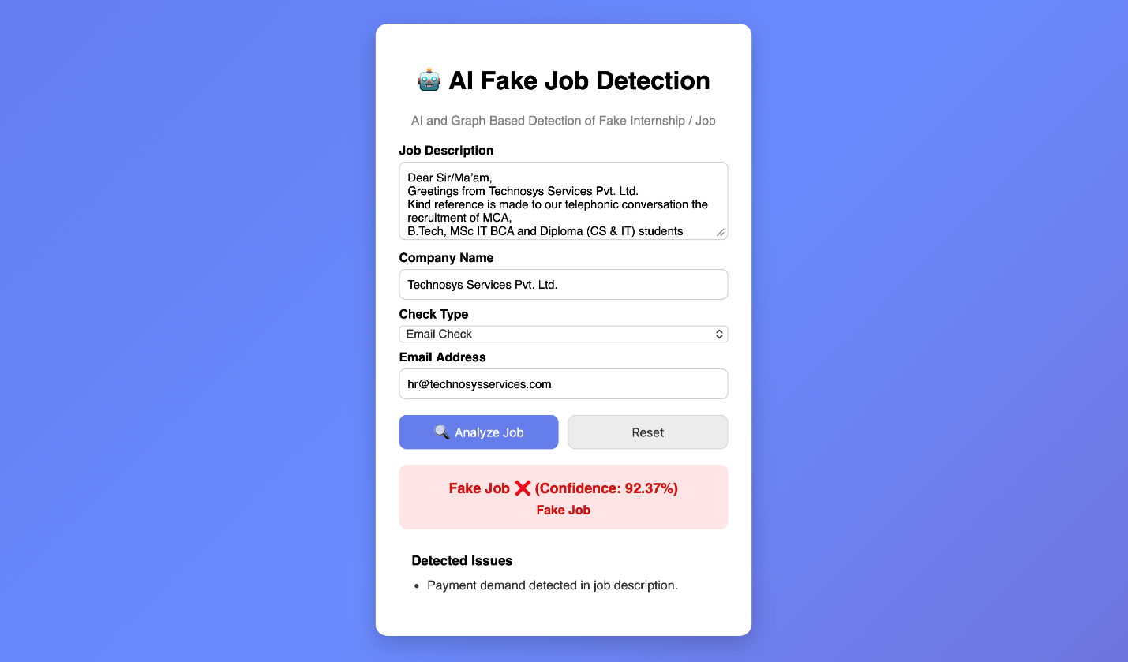

5.2.4) Result3

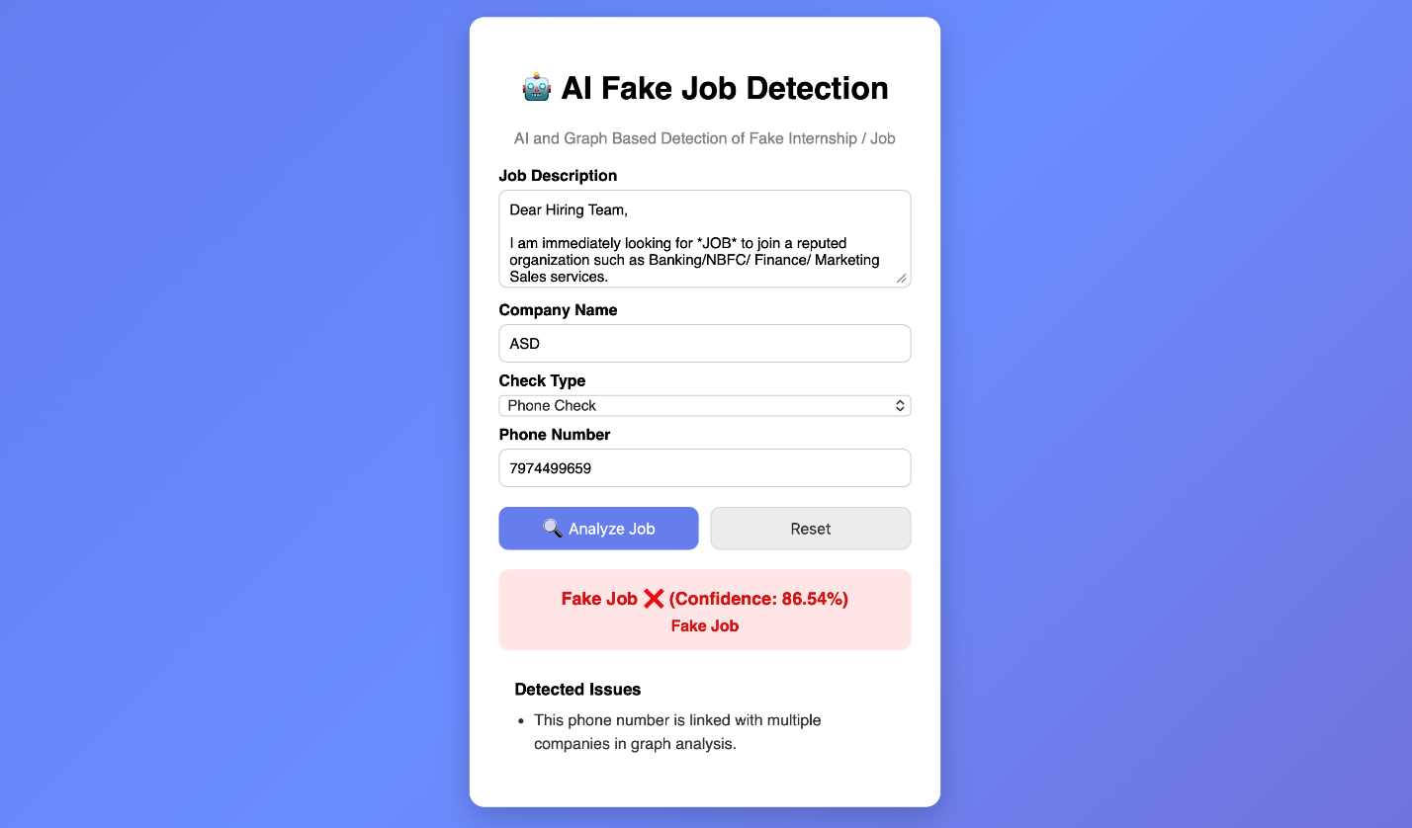

CHAPTER 6

CONCLUSION
In the modern digital era, online recruitment platforms have become the primary source for students and job seekers to explore internships and employment opportunities. While these platforms offer convenience and accessibility, they have also led to a significant increase in fraudulent job postings. These fake opportunities often mislead users by offering unrealistic benefits, collecting sensitive personal information, or demanding money under false pretenses. Traditional verification methods are manual, time-consuming, and not scalable, making it difficult to detect such fraud effectively.
To address this challenge, the proposed system titled “AI & Graph-Based Detection of Fake Internship/Job” presents a comprehensive and intelligent solution. The system integrates machine learning techniques with graph-based analysis to detect suspicious job postings and uncover hidden fraud patterns. By using NLP-based text processing along with TF-IDF feature extraction and Logistic Regression, the system analyzes job descriptions and identifies linguistic patterns commonly associated with fraudulent content.
In addition to textual analysis, the system incorporates graph-based modeling to represent relationships between entities such as job posts, email addresses, phone numbers, and domains. This structural approach helps in identifying repeated patterns, shared contact details, and clusters of suspicious activities. As a result, the system is capable of detecting not only individual fake postings but also organized fraud networks that operate across multiple platforms.
The integration of these two approaches—text-based classification and graph-based analysis—enhances the overall accuracy, reliability, and robustness of the system. The use of a dashboard developed using Streamlit further improves usability by providing real-time alerts, risk scores, and visual representations of fraud connections. This makes it easier for users and administrators to monitor suspicious activities and take timely action.
Throughout the development of this project, a systematic approach was followed, including data collection, preprocessing, model training, graph construction, and evaluation. Each stage was carefully implemented to ensure the system performs efficiently in real-world scenarios. The results demonstrate that combining AI techniques with graph analysis significantly improves the detection of fraudulent job postings compared to traditional methods.
This system is particularly beneficial for students and job seekers, as it helps them avoid scams and make informed decisions while applying for opportunities. It can also assist educational institutions, job portals, and regulatory bodies in monitoring and preventing recruitment fraud more effectively. The scalable design of the system ensures that it can handle large datasets and adapt to growing digital recruitment environments.
In conclusion, the project successfully demonstrates how the integration of artificial intelligence and graph-based techniques can provide a powerful and practical solution to the problem of fake internship and job postings. With further enhancements such as real-time data integration, advanced machine learning models, and multilingual support, the system has strong potential to evolve into a fully automated and widely deployable fraud detection platform, ensuring a safer and more trustworthy online recruitment ecosystem.

FUTURE SCOPE

1. Advanced AI-Based Detection Models
Future versions of the system can incorporate more advanced machine learning and deep learning models to improve detection accuracy. Techniques such as ensemble learning and neural networks can help identify complex fraud patterns that basic models may miss.

2. Real-Time Fraud Detection
The system can be integrated with live job portals, social media platforms, and messaging applications to analyze job postings in real time. This will allow instant detection and alert generation for suspicious activities.

3. Predictive Fraud Analysis
Instead of only detecting existing fake jobs, future systems can predict potential fraud based on trends, repeated behaviors, and historical data. This proactive approach can help prevent scams before they occur.

4. Enhanced Graph Analysis using GNNs
The current graph-based approach can be improved using Graph Neural Networks (GNNs), which can better analyze complex relationships between entities such as emails, phone numbers, and domains, leading to more accurate detection of fraud networks.

5. Multilingual Support
The system can be extended to support multiple languages, enabling detection of fake job postings across different regions and increasing accessibility for a global user base.

6. Browser Extension Integration
A browser extension can be developed to automatically scan job postings while users browse websites and provide instant warnings for suspicious content.

7. Mobile Application Development
A dedicated mobile application can be introduced to provide real-time alerts, notifications, and easy access to the dashboard for users on smartphones.

8. Automated Reporting System

The system can be integrated with job portals or regulatory authorities to automatically report detected fraudulent postings, helping in faster action against scammers.

9. Improved User Interface and Visualization
Future improvements can enhance the dashboard with more advanced visualizations, interactive graphs, and better user experience for easier understanding of fraud patterns.

10. Continuous Learning System
The model can be designed to continuously learn from new data and user feedback, ensuring that it adapts to evolving fraud techniques and remains effective over time.
Multi-language and Regional Support

Expanding multi-language and regional support is important to make the fake job detection system effective across different countries and user groups. Recruitment fraud exists globally, and supporting multiple languages and regional patterns will improve detection accuracy and usability. The following enhancements can be considered:

1.Advanced Language Models
The system can be extended using advanced NLP models that support multiple languages. These models can analyze job postings written in different languages and detect suspicious patterns with high accuracy, even in low-resource languages.

2. Contextual Localization
Instead of simple translation, the system can understand regional context such as local job formats, common hiring practices, and region-specific scam patterns. This will help in identifying fraud that is tailored to specific locations.

3. Real-Time Translation and Detection
The system can integrate real-time translation features to analyze job postings in any language instantly. This allows users to detect fraudulent content across global platforms without language barriers.

4. Regional Pattern Recognition
Different regions may have different types of job scams. The system can be trained to recognize region-specific fraud indicators such as common fake company names, typical salary traps, or frequently reused contact details in a particular area.

5. Compliance with Regional Regulations
As the system expands globally, it should follow regional data privacy and cybersecurity regulations. This ensures safe handling of user data and builds trust among users.

6. Localized Dashboard and Alerts
The dashboard can be customized to display alerts, notifications, and insights in the user’s preferred language. This improves accessibility and makes the system more user-friendly for non-English users.

User Engagement, Alerts & Access Model
To improve user engagement and ensure continuous usage of the fake job detection system, future enhancements can include advanced alert systems, user access models, and engagement features. These improvements will help users stay informed and protected from recruitment fraud..

1. Personalized Alerts
The system can generate personalized alerts based on user activity, such as job searches, preferred domains, or previously viewed postings. Users will receive notifications when suspicious or high-risk job postings match their interests.

2. Smart Notification System
Real-time notifications can be sent via email, SMS, or in-app alerts whenever a fraudulent job post is detected. This ensures users are immediately warned before interacting with suspicious content.

3. Risk-Based Access Levels
The platform can introduce role-based or subscription-based access (e.g., basic and advanced users). Advanced users or institutions can access detailed analytics, full graph visualizations, and deeper fraud insights.

4. Gamification for Awareness
Gamification elements such as badges, scores, or awareness levels can be introduced to encourage users to report suspicious jobs and stay engaged with the platform. This will promote community participation in fraud detection.

5. Automated Reporting and Feedback System
Users can report suspicious job postings, and the system can learn from this feedback to improve detection accuracy. Automated reporting to job portals or authorities can also be implemented.

6. Transparency in Risk Scoring
The system can provide explanations for why a job posting is marked as suspicious (e.g., reused phone number, fake domain, unrealistic salary). This builds trust and helps users understand fraud indicators.

7. Integration with External Platforms
The system can be integrated with job portals, university placement systems, and social media platforms to automatically scan and flag suspicious postings.

8. Dashboard Customization
Users can customize their dashboard to track specific job categories, risk levels, or entities (emails, phone numbers). This improves usability and relevance.

9. Continuous Learning and Updates
The system can continuously update its models based on new fraud patterns and user interactions, ensuring it stays effective against evolving scams.

10. Community-Based Fraud Awareness
A community feature can be added where users share experiences, warnings, and feedback about suspicious job postings, helping others stay safe.

REFERENCES

[1] D. Ranparia, S. Kumari, and A. K. Sahani, “Fake Job Prediction using Sequential Network,” in Proc. 2020 IEEE 15th International Conference on Industrial and Information Systems (ICIIS), 2020, pp. 339-343.
[2] A. Amaar, W. Aljedaani, F. Rustam, S. Ullah, V. Rupapara, and S. Ludi, “Detection of Fake Job Postings by Utilizing Machine Learning and Natural Language Processing Approaches,” Neural Processing Letters, vol. 54, pp. 2219-2247, 2022.
[3] S. Mahbub, E. Pardede, and A. S. M. Kayes, “Online Recruitment Fraud Detection: A Study on Contextual Features in Australian Job Industries,” IEEE Access, vol. 10, pp. 82776-82787, 2022.
[4] M. Naude, K. J. Adebayo, and R. Nanda, “A machine learning approach to detecting fraudulent job types,” AI and Society, vol. 38, no. 2, pp. 1013-1024, 2023.
[5] Z. Ullah and M. Jamjoom, “A smart secured framework for detecting and averting online recruitment fraud using ensemble machine learning techniques,” PeerJ Computer Science, vol. 9, e1234, 2023.
[6] G. Malaichamy, C. H. Muntean, and A. A. Simiscuka, “Online Job Posting Authenticity Prediction with Machine and Deep Learning: Performance Comparison Between N-Gram and TF-IDF,” in Deep Learning Theory and Applications, CCIS, vol. 2171, 2024, pp. 143-162.
[7] K. Taneja, J. Vashishtha, and S. Ratnoo, “Fraud-BERT: transformer based context aware online recruitment fraud detection,” Discover Computing, vol. 28, art. no. 9, 2025.
[8] A. J. Meza-Alarcon, L. M. De La Cruz-Mallqui, and W. Ticona, “Using Machine Learning and Deep Learning to Detect Recruitment Scams on Websites: A Systematic Review,” in System Design in Software Engineering, LNNS, vol. 1471, 2025, pp. 443-463.
[9] N. Goyal, N. Sachdeva, and P. Kumaraguru, “Spy the Lie: Fraudulent Jobs Detection in Recruitment Domain using Knowledge Graphs,” in Knowledge Science, Engineering and Management, LNCS, vol. 12816, 2021, pp. 612-623.
[10] D. Cheng et al., “Graph neural networks for financial fraud detection: a review,” Frontiers of Computer Science, vol. 19, art. no. 199609, 2025.
[11] C. Lou, Y. Wang, J. Li, Y. Qian, and X. Li, “Graph neural network for fraud detection via context encoding and adaptive aggregation,” Expert Systems with Applications, vol. 261, art. 125473, 2025.
[12] P. Li, Y. Xie, X. Xu, J. Zhou, and Q. Xuan, “Phishing Fraud Detection on Ethereum Using Graph Neural Network,” in Blockchain and Trustworthy Systems, CCIS, vol. 1679, 2022, pp. 362-375.
[13] Federal Trade Commission, “New FTC Data Show Skyrocketing Consumer Reports About Game-Like Online Job Scams,” Dec. 2024.
[14] Federal Bureau of Investigation, IC3 Annual Report, 2024.
[15] Better Business Bureau, “Employment scams target college students,” Jul. 2024.

